News release
Solar Energy

Outlook for 2023

Production at Full Speed

(Wels, December 21, 2022) In 2022, Fronius invested EUR 187 million in expanding and converting the production site at Sattledt (Austria) and the competence center for inductive components in Krumau (Czech Republic) – and will increase investment to more than EUR 230 million in the coming year. This will result in additional production lines, jobs, and a stable manufacturing situation.

Fronius is investing hugely in expanding production. “We have increased total floor space from 41,000 m² to 69,000 m². Our production facilities are operating constantly at full speed to meet rocketing demand the best we can,” says Martin Hackl, Global Director Marketing and Sales, Business Unit Solar Energy, Fronius International GmbH. High value creation in Europe is top priority for Fronius; this is the only way that high quality and safety standards can be ensured. “95 percent of our contract partners come from Europe,” states Martin Hackl.

New Production Lines
The northern expansion of the production plant in Sattledt, Austria, is already up and running. The Fronius Tauro has been manufactured there since the middle of August. The existing manufacturing facilities are being converted, resulting in an additional production line for the Fronius GEN24 Plus this year. Two more will be added in 2023. “The additional production lines help us to meet the high demand”, explains Martin Hackl.

High Output Versus PV Boom
„Output at Fronius is higher than ever,” says Martin Hackl. In 2022, a total of almost 32,000 inverters per month were produced. By the end of 2023, this should be more than 52,000 per month, a rise of more than 65 percent. This meets a real boom in PV. “Photovoltaics are more sought-after than ever before, and demand is exploding,” says Martin Hackl. At the same time, the pandemic presented companies around the world with new challenges. Even Fronius was not spared. “Despite difficult circumstances such as unstable supply chains and shortages of components and staff, we were able to secure supply and stabilize production,” reports Martin Hackl.

Sustainable Investment at All Sites
Investment in energy-saving technologies and conscious consumption of resources are principles that are firmly established at Fronius: Two ice tanks are used at the production site at Sattledt for heating in winter and cooling in summer. It is currently the largest system of its type in Europe. A further highlight is the fully automatic high-bay warehouse, which provides space for 7,000 pallets and 12,500 containers for small parts.

At the Czech site in Krumau, the next phase of expansion is already being planned, even though the most recent addition has only just been finished. Plans for the next five years include a doubling of the workforce and a substantial expansion of production space.

Many of the 25 branches of Fronius Solar Energy are investing in the future over the coming year. For instance, Fronius Italy will put a new PV system and charging stations for electric cars into operation. At Fronius in Switzerland, field staff will be using twelve electric vehicles to get around from 2023. Fronius is also investing in new staff. Martin Hackl expects strong growth over the next two years: “We’re looking for around 1,300 new employees worldwide by the end of 2023.”

Words: 527
Characters (including spaces): 3,268

Images

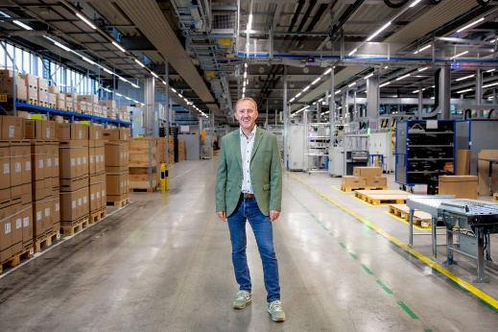

Martin Hackl, Global Director Marketing and Sales, Business Unit Solar Energy, Fronius International GmbH.
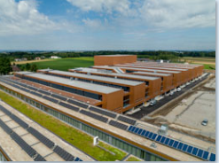

The northern expansion of the Fronius production plant at Sattledt in Austria is already up and running.
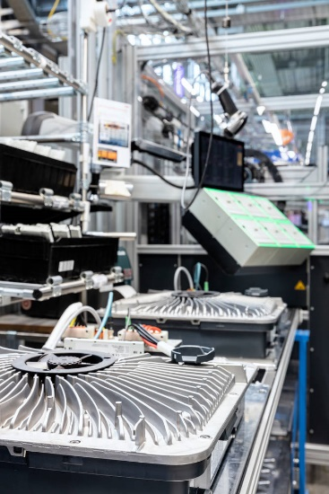
Output at Fronius is higher than ever.
Photo credits: Fronius International GmbH, reproduction free of charge

Business Unit Solar Energy
Founded in 1992, the Fronius Business Unit (BU) Solar Energy is celebrating its 30th anniversary this year. Under the motto “Energize your life”, we develop innovative solutions with which solar energy can be generated, stored, distributed and consumed cost-efficiently and intelligently. Fronius Solar Energy makes it possible to use the sun 24 hours a day, paving the way for a future worth living in, in which renewable energies cover 100 percent of the world’s energy needs. Our solutions are sustainably developed and produced entirely in Europe – mainly in Austria. Fronius Solar Energy has 26 branches around the world and can point to a total output of more than 25 gigawatts of installed inverters to date. Sales are made via a global competence network of installation, service, and sales partners.
We are Fronius.
Over 6100 employees worldwide, a current export share of 89 percent, and 1366 active patents: that’s us, that’s Fronius. Founded in 1945 as a regional one-man operation, we are now a global player - a fact that is impressively demonstrated by our 37 international subsidiaries and our network of sales partners in more than 60 countries. And yet, at our core, we are still a family-owned company from Austria, active in photovoltaics, welding, and battery charging technology. We have always developed products and solutions for a future worth living, offering our customers an all-in-one package in the process: from advance planning and consulting to ongoing monitoring and a repair service tailored to their specific needs. We are innovative. We are curious. We are Fronius.

Enquiry note
Fronius International GmbH, Mag. Andrea SCHARTNER,
+43 664 88536765, schartner.andrea@fronius.com,
Froniusplatz 1, 4600 Wels, Austria
Laura NACHBAUER, +43 664 677411572, nachbauer.laura@fronius.com, Froniusplatz 1, 4600 Wels, Austria.

Elfriede HIRSCH, +43 664 6213775, hirsch.elfriede@fronius.com, Froniusplatz 1, 4600 Wels, Austria.

Specimen copy
a1kommunikation Schweizer GmbH, Rüdiger KEMPA,
rke@a1kommunikation.de
Oberdorfstraße 31A, 70794 Filderstadt, Germany

If you no longer wish to receive press releases from Fronius International GmbH (Business Unit Solar Energy) please reply with UNSUBSCRIBE to the e-mail address cancellation@fronius.com.

