Press Release
Solar Energy

Review: Production Power Summit 2023

Fronius Production Power Summit 2023
Joining forces for a sunny future
Wels, October 5, 2023. October 5 at Fronius was all about sustainable, future-proof value creation. During the Production Power Summit 2023, the company presented its vision for working together with the European solar industry to achieve 24 hours of sun.
The trends in recent years have clearly demonstrated the continuously growing importance of solar energy in the worldwide expansion of renewable energy supplies. “As the heart and brains of PV systems, inverters are supporting elements of the power grids of the future and therefore of critical infrastructure. As a European manufacturer, we see this as a great responsibility that we are consciously fulfilling with proactive strategies and technological innovations. We are therefore especially pleased to have the chance to discuss opportunities for strengthening the European PV industry together with suppliers, distribution partners and installers, and – in line with our internationalization strategy – to look beyond our borders to create a solid foundation for sustainable growth,” said Elisabeth Engelbrechtsmüller Strauß, CEO Fronius International, in her opening remarks for the event.
“The situation for many companies in the European solar market is tense. We are also feeling this, especially since we’ve had to deal with our own challenges in recent years,” explained Martin Hackl, Global Director Marketing and Sales, Business Unit Solar Energy, Fronius International GmbH. He added: “This means it is all the more important to take systematic action together to strengthen our structures. In light of this, we have placed our production on a broad basis in order to dramatically increase the availability of European inverters. But this is only a first step, because we will only be able to supply the European market with products from local companies if the entire industry demonstrates strong assertiveness.”

Production power on the right track
At the Production Power Summit 2023, Fronius presented concepts for managing resilient supply chains as well as the measures already in place to increase output capacity – including the expansion of production in Sattledt near Wels. The production area has been almost doubled, significantly increasing production capacities in the last two years. A tripling of storage capacity has further strengthened product availability. And an innovative logistics system is supplying twice as many solar production lines with pre-commissioned component packages. Automated final tests and a continuous load test are performed in the updated test center. Devices that pass the tests are transported on to the dispatch area. A new high-bay warehouse provides support here. Storage and retrieval is also fully automated. Once orders for national and international shipping are completed, the products are sent to the outgoing goods department, where capacities have also been doubled. As a result, even more inverters arrive at their destination every day.

Strong roots in Europe
Also during the event, the company invited two partner companies, Thomas Schmalzer, CEO TCG Unitech GmbH and Bernhard Fischer, CEO ebm Papst-Motoren und Ventilatoren GmbH, to join a panel discussion on ways to increase the resilience of European value chains in the PV industry. During this discussion, Walburga Hemetsberger, CEO SolarPower Europe, was also welcomed on stage. “We are at a decisive point in the energy transition,” Ms. Hemetsberger emphasized. “Renewable energies must be expanded more quickly to maintain Europe’s competitiveness and energy security. PV will play a crucial role in this. At the same time, it’s important to strengthen European PV generation along the entire value chain in Europe. This also includes manufacturers of critical components for PV systems, such as inverters. Europe as a business location must be made more attractive again. We support the efforts for greater resilience of European supply chains. As a result, we are strengthening local companies and fostering their strong innovative spirit. This is where we see our duty as the voice of the solar industry in Europe – to the companies and to society as a whole.”
Thomas Herndler, COO Fronius International GmbH, described measures Fronius has already taken in Operations to achieve this, pointing out that “a joint strategy for the sustainable supply of domestic and international markets by European companies knows no borders. In addition to expanding our own production facility in Sattledt, we are also bringing production partners on board to manufacture inverters for Fronius at other locations in Central Europe – to the same quality criteria and standards that are applied at the plant in Sattledt, of course. This cooperation further boosts the scalability and flexibility of our production. This positions us perfectly to produce more than 70,000 inverters per month in the coming year.”

Looking beyond the continent
As a family-owned company, Fronius is proud of its roots in the foothills of the Alps and, with its 37 subsidiaries worldwide, it has long been a global player. The Business Unit Solar Energy is active in the PV market in 26 of these subsidiaries. “Internationalization has enabled our strong growth in the past and will continue to strengthen us as a European manufacturer in the future,” said Fronius CEO Elisabeth Engelbrechtsmüller Strauß. She continued: “We monitor and know our markets very well and strengthen our position where we see growing opportunities. We have been represented in the United States since 2002 at our site in Portage, Indiana. We are currently setting up a new research and development department there, to be closer to the needs of the market. Products and features are further developed according to local requirements, making the on-site development department a trailblazer in the production of customized solutions. The next step is to set up our own production lines in Portage for inverters. By building a local network of suppliers, we are creating a sustainable value chain to optimize supply for the American and Asia-Pacific markets. By implementing this ‘local for local’ approach, we are enhancing the global resilience and healthy growth of our company.”

Partnership and cohesion needed
What is needed to complement these strategic steps is a strong sense of togetherness in the industry, Hackl stresses. “In addition to increasing quantities through expanded production capacities, we continue to focus primarily on quality through partnership and service. This is what has distinguished us as Fronius Solar Energy for more than 30 years and what sets us apart from other providers. The basis for this is a strong network of mainly European suppliers, global sales partners and installation partners. Transparent communication and mutual trust make these relationships especially sustainable – which ultimately enhances the security and resilience of our supply chain and product availability, all the way to the consumer.”

Counting on Fronius
Overall, the Production Power Summit 2023 shows that Fronius has armed itself well against the growing competitive pressure. The balanced increase in quantity with simultaneous investment in quality aspects puts the company in a position from which global markets can be ideally supplied. The company offers its customers a variety of points of contact with a comprehensive landscape of apps and the tried-and-tested service hotline. The high degree of reparability of the products further increases sustainability and longevity. “With our well-designed portfolio, we offer prosumer markets exciting ‘plug and use’ solutions that can be used to perfectly manage the areas of electricity, heating, cooling and mobility. Demand for our products therefore remains unabatedly high,” Hackl said. “We are more than ready and well positioned to meet it,” he added optimistically.

Words: 1,201
Characters: 7,846 (with spaces)

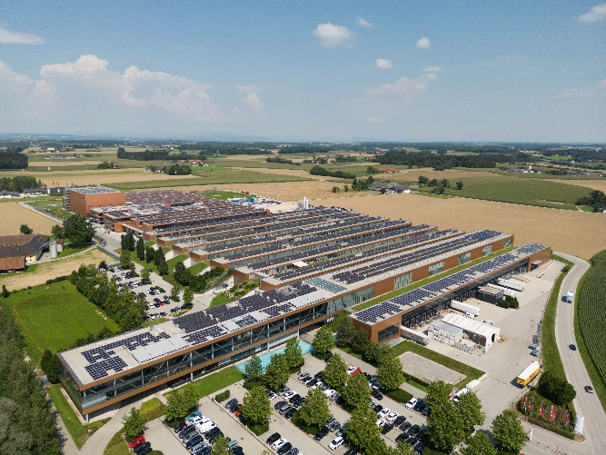 | Fronius’s production capacities have significantly increased thanks to the production area expansion in Sattledt.
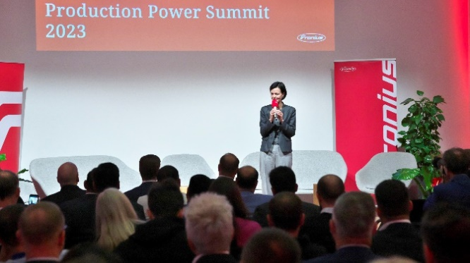 | Elisabeth Engelbrechtsmüller-Strauß, CEO of Fronius International GmbH, opened the Production Power Summit and stressed the importance of an independent European PV industry.
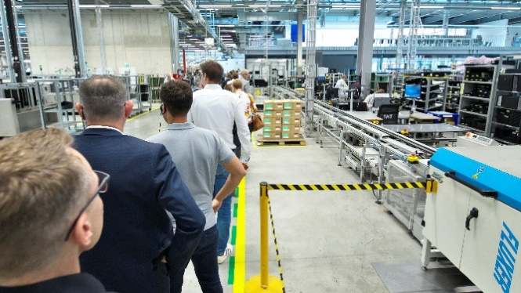 | Around 150 visitors were personally shown Fronius’ increased production capacities in Sattledt.
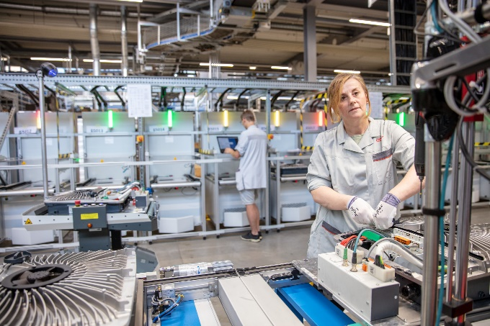 | The production lines for the Fronius GEN24 Plus series inverters have been doubled.
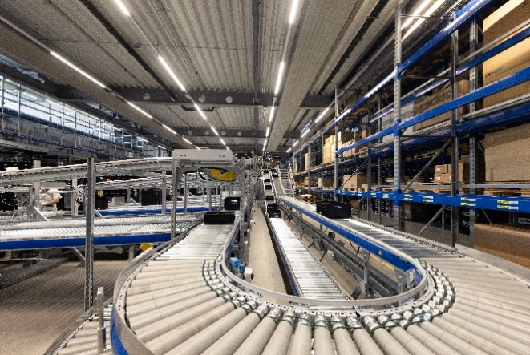 | The state-of-the-art order picking center also received a boost in production capacities.
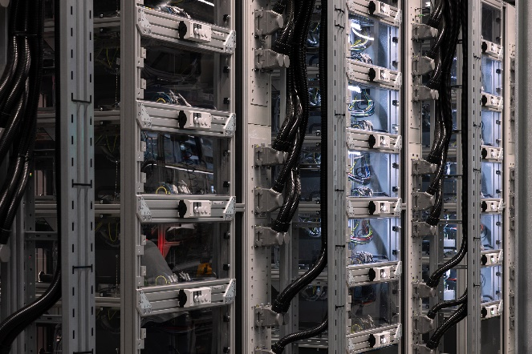 | Final tests and continuous load tests are conducted automatically in the modernized test center.

Photo credits: Fronius International GmbH, reprint free of charge

Business Unit Solar Energy
The Fronius Business Unit (BU) Solar Energy, which was founded in 1992, develops innovative solutions that generate, store, distribute and consume solar energy cost-efficiently and intelligently, all under the motto “energize your life”. Fronius Solar Energy makes it possible to use the sun 24 hours a day, paving the way for a future worth living in, in which renewable energies cover 100 percent of the world’s energy needs. Our solutions are sustainably developed and produced entirely in Europe – mainly in Austria. Fronius Solar Energy has 26 branches around the world and can point to a total output of more than 29 gigawatts of installed inverters to date. Sales are made via a global competence network of installation, service, and sales partners.

We are Fronius.
Over 7000 employees worldwide, a current export share of 87 percent, and 1446 active patents: that’s us, that’s Fronius. Founded in 1945 as a regional one-man operation, we are now a global player - a fact that is impressively demonstrated by our 37 international subsidiaries and our network of sales partners in more than 60 countries. And yet, at our core, we are still a family-owned company from Austria, active in photovoltaics, welding, and battery charging technology. We have always developed products and solutions for a future worth living, offering our customers an all-in-one package in the process: from advance planning and consulting to ongoing monitoring and a repair service tailored to their specific needs. We are innovative. We are curious. We are Fronius.

Enquiry note
Fronius International GmbH, Mag. Fabian SCHWARZ
+43 664 88536765, schwarz.fabian@fronius.com,
Froniusplatz 1, 4600 Wels, Austria

Specimen copy
a1kommunikation Schweizer GmbH, Rüdiger KEMPA,
rke@a1kommunikation.de
Oberdorfstraße 31A, 70794 Filderstadt, Germany

If you no longer wish to receive press releases from Fronius International GmbH (Business Unit Solar Energy) please reply with UNSUBSCRIBE to the e-mail address cancellation@fronius.com.

