News release
Solar Energy

Further development comes up trumps

New features for the Fronius Wattpilot

(Wels, 11/24/2022) There’s a lot going on with the intelligent charging station from Fronius. The Fronius Wattpilot boasts load management, greater flexibility, a higher IP rating, and even more sustainability. Designed to move.

Constant improvement is part of the Fronius philosophy. “We work on enhancing our products and solutions every day of the week. The Fronius Wattpilot is the most recent example. The latest software features bring a host of benefits, both for the installer and for the PV system owner,” explains Martin Hackl, Global Director Marketing & Sales Business Unit Solar Energy, Fronius International GmbH. Value creation also plays a major role in this: in keeping with the Fronius sustainability strategy, components from Europe are used to avoid long transport routes.

New features for the Fronius Wattpilot
One new feature is the OCPP (Open Charge Point Protocol) – a standardized interface for the management of charging stations. It enables charging reports to be created and load management to take place.

There’s also good news for those who like to keep an eye on what's happening with all their energy flows: the Wattpilot is now shown in Fronius Solar.web. This gives users a uniform visualization and the option to troubleshoot directly in the free monitoring tool. In addition, the Wattpilot has been given a new look, with the modern housing providing a higher IP rating of IP55. What’s more, the WLAN range has been improved, increasing flexibility at the installation site.

All these enhancements are not only available for the existing versions, but also for two additional models: the Wattpilot Home 22 J and the Wattpilot Go J 22 AUS (for Australia).

Energy-optimized charging
The Dynamic Load Balancing feature will also become available for all Wattpilot charging stations at the end of the year.* Electric vehicles are usually charged at high power, which means that, if several vehicles are connected at the same time, the maximum connected load of the household will often be exceeded. Dynamic Load Balancing ensures the power is optimally distributed, resulting in reliable charging without the need to invest in a large and expensive connection infrastructure. Up to three electric vehicles can be charged simultaneously in an energy-optimized manner using Dynamic Load Balancing. The energy required is dynamically distributed and controlled among the vehicles being charged.
The Wattpilot can already detect when the household connected load is exceeded and reacts to this by giving priority to the loads in the house (heat pump, Ohmpilot, cooker, etc.).

Dream team: PV and e-mobility
E-mobility only really makes sense in combination with a photovoltaic system, since the cheapest way to charge electric vehicles is using self-generated photovoltaic power. Plus, the green electricity significantly improves the life cycle analysis.
* This feature will be available at the end of 2022 via a software update.

Words: 461
Characters: 2,931 (incl. spaces)

Images


E-mobility is the most recent addition to the visualizations in Fronius Solar.web.
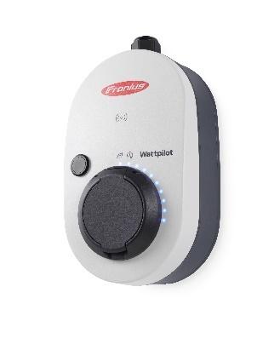

The modern design of the Fronius Wattpilot housing ensures a higher IP rating (IP55).

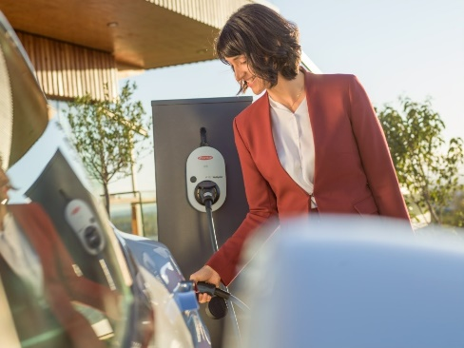

Dream team: PV and e-mobility.

Photo credits: Fronius International GmbH, reproduction free of charge

Business Unit Solar Energy
Founded in 1992, the Fronius Business Unit (BU) Solar Energy is celebrating its 30th anniversary this year. Under the motto “Energize your life”, we develop innovative solutions with which solar energy can be generated, stored, distributed and consumed cost-efficiently and intelligently. Fronius Solar Energy makes it possible to use the sun 24 hours a day, paving the way for a future worth living in, in which renewable energies cover 100 percent of the world’s energy needs. Our solutions are sustainably developed and produced entirely in Europe – mainly in Austria. Fronius Solar Energy has 26 branches around the world and can point to a total output of more than 25 gigawatts of installed inverters to date. Sales are made via a global competence network of installation, service, and sales partners.
We are Fronius.
Over 6100 employees worldwide, a current export share of 89 percent, and 1366 active patents: that’s us, that’s Fronius. Founded in 1945 as a regional one-man operation, we are now a global player - a fact that is impressively demonstrated by our 37 international subsidiaries and our network of sales partners in more than 60 countries. And yet, at our core, we are still a family-owned company from Austria, active in photovoltaics, welding, and battery charging technology. We have always developed products and solutions for a future worth living, offering our customers an all-in-one package in the process: from advance planning and consulting to ongoing monitoring and a repair service tailored to their specific needs. We are innovative. We are curious. We are Fronius.

Enquiry note
Fronius International GmbH, Mag. Andrea SCHARTNER,
+43 664 88536765, schartner.andrea@fronius.com,
Froniusplatz 1, 4600 Wels, Austria
Laura NACHBAUER, +43 664 677411572, nachbauer.laura@fronius.com, Froniusplatz 1, 4600 Wels, Austria.

Elfriede HIRSCH, +43 664 6213775, hirsch.elfriede@fronius.com, Froniusplatz 1, 4600 Wels, Austria.

Specimen copy
a1kommunikation Schweizer GmbH, Rüdiger KEMPA,
rke@a1kommunikation.de
Oberdorfstraße 31A, 70794 Filderstadt, Germany

If you no longer wish to receive press releases from Fronius International GmbH (Business Unit Solar Energy) please reply with UNSUBSCRIBE to the e-mail address cancellation@fronius.com.

