Press release
Solar Energy

30 years of Fronius Solar Energy

High targets and sustainable growth

(Wels, 09/02/2023) Fronius Solar Energy has been developing innovative products and solutions with which solar energy can be generated, stored, distributed and consumed cost-efficiently and intelligently since 1992. We have also set ambitious goals for the coming years, with a focus on sustainable growth and value creation in Europe, as well as the continuous development of products and solutions.

The targets for 2023 are clear: 3,000 Fronius inverters are to be installed every day by the end of the year. In doing so, Fronius Solar Energy will have installed 35 GW of power since the first Fronius Sunrise¹ was sold. That is 3.9 million inverters, generating 46.8 TWh of green energy every year, corresponding to 44 hydroelectric power stations².
Martin Hackl, Global Director Marketing & Sales Business Unit Solar Energy, Fronius International GmbH, already sees the plans for the coming years clearly: “Our goal is a strong digital and functional networking of Fronius systems with energy sector integration products in order to bring more solar power to the sectors of heating, cooling and mobility. This ensures further growth towards our goal of 24 hours of sun.” Finding pioneering solutions for technical challenges has been the guiding principle of the Austrian family-owned company right from the very beginning.
The continuous improvement of products and solutions as well as the strong focus on sustainability and value creation in Europe are top priorities, which can be seen in the latest developments:
New version of the Fronius Tauro
The new 30 amperes version of the Fronius Tauro³ will be available from February 2023, providing a solution for the ever-increasing number of high-current modules. These are PV modules with advanced solar wafers which carry more current and therefore help to reduce system costs. The new version of the Tauro boasts maximum flexibility in terms of system design and low total system operating costs.

Fronius GEN24 Plus – climate benefits of the entire system now even higher
A highlight in the sustainability work at Fronius is the life cycle assessment (LCA) for the Fronius GEN24 Plus and the Fronius Tauro. “Evidence-based sustainability is just as important to us as the integration of results into product development to continuously improve our sustainability performance,” says Katrin Helmberger, Head of Corporate Sustainability, Fronius International GmbH. Data freshness is highly relevant here, which is why the life cycle assessment is updated as required.
The most recent calculations of the Fronius GEN24 Plus LCA show that the climate benefits of the entire system have even improved. The CO_{2e} payback time has reduced from 1.2–5.5 years to 0.7–3.3. years⁴.
We are striving for a complete decarbonisation of all Fronius company premises by 2025. Furthermore, at Fronius we are already using 100 percent green power and have also cut greenhouse gas intensity in half between 2014 and 2021. “These results speak for themselves. We focus on planning and implementing technical and organisational measures instead of compensating for emissions,” explains Helmberger.

¹ The Fronius Sunrise has been used to implement small photovoltaic systems ranging in size from 600 Wp to 1,400 Wp.
² Comparison to Vienna-Freudenau hydroelectric power station
³ Fronius Tauro Direct version
⁴ Range: best case – worst case

Words: 526
Characters (including spaces): 3,338

Images

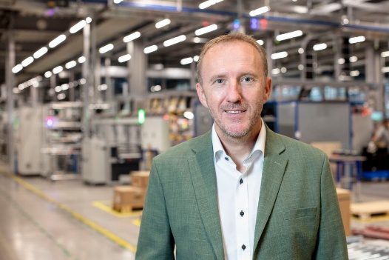

Martin Hackl, Global Director Marketing & Sales Business Unit Solar Energy, Fronius International GmbH.

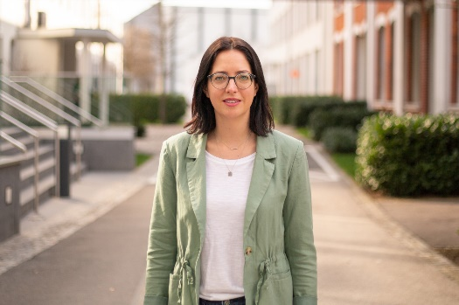

Katrin Helmberger, Head of Corporate Sustainability, Fronius International GmbH.
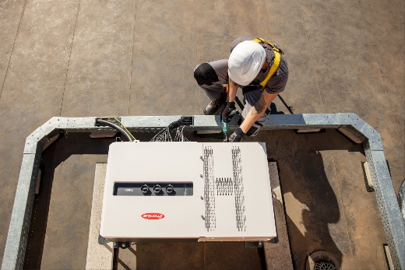

The new 30 amperes version of the Fronius Tauro is our solution for an ever-increasing number of high-current modules.
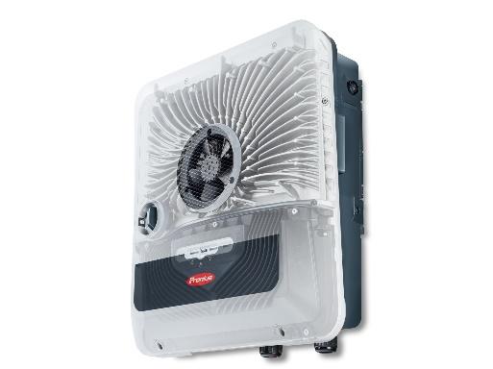

The CO_{2e} payback time has reduced from 1.2–5.5 years to 0.7–3.3 years.

Photo credits: Fronius International GmbH, reproduction free of charge

Business Unit Solar Energy
Founded in 1992, the Fronius Business Unit (BU) Solar Energy is celebrating its 30th anniversary this year. Under the motto “Energize your life”, we develop innovative solutions with which solar energy can be generated, stored, distributed and consumed cost-efficiently and intelligently. Fronius Solar Energy makes it possible to use 24 hours of sun every day, paving the way for a future worth living in, in which renewable energies cover 100 percent of the world’s energy needs. Our solutions are sustainably developed and produced entirely in Europe – mainly in Austria. Fronius Solar Energy has 26 branches around the world and can point to a total output of more than 25 gigawatts of installed inverters to date. Sales are made via a global competence network of installation, service, and sales partners.
We are Fronius.
Over 6100 employees worldwide, a current export share of 89 percent, and 1366 active patents: that’s us, that’s Fronius. Founded in 1945 as a regional one-man operation, we are now a global player - a fact that is impressively demonstrated by our 37 international subsidiaries and our network of sales partners in more than 60 countries. And yet, at our core, we are still a family-owned company from Austria, active in photovoltaics, welding, and battery charging technology. We have always developed products and solutions for a future worth living, offering our customers an all-in-one package in the process: from advance planning and consulting to ongoing monitoring and a repair service tailored to their specific needs. We are innovative. We are curious. We are Fronius.

Contact for further inquiries
Fronius International GmbH, Andrea SCHARTNER,
+43 664 88536765, schartner.andrea@fronius.com,
Froniusplatz 1, 4600 Wels, Austria
Natalie WOODFORD, +44 1908 512 301, woodford.natalie@fronius.com, Maidstone Road, Kingston, Milton Keynes, MK10 0BD, United Kingdom.

Kenny HO, +61 3 8340 2953, Ho.Kenny@fronius.com, 90-92 Lambeck Drive, Tullamarine VIC 3043, Australia.

Specimen copy
a1kommunikation Schweizer GmbH, Rüdiger KEMPA,
rke@a1kommunikation.de
Oberdorfstraße 31A, 70794 Filderstadt, Deutschland

If you no longer wish to receive press releases from Fronius International GmbH (Business Unit Solar Energy) please reply with UNSUBSCRIBE to the e-mail address cancellation@fronius.com.

