News release

Intersolar 2022

Fronius presents real sustainability

(Wels, 02/03/2022) Fronius will be presenting real sustainability on three exhibition stands totaling 668 m² between May 11-13 at Intersolar Europe – and, for the first time, at Power2Drive Europe as well. Innovative products and solutions from the residential, commercial, and mobility sectors as well as digital tools will be on display.

“There’s a lot of talk about sustainability. We are presenting real sustainability. This comes in the shape of our products and solutions, which are produced in the heart of Europe and whose life cycles are designed for sustainability, as well as our long-standing and sustainable partnerships,” explains Martin Hackl, Global Director of the Business Unit Solar Energy, Fronius International GmbH, proudly and adds: “For 30 years we have been developing our products and solutions with the wellbeing of future generations in mind and we also run our business in a responsible manner.”

Energy solutions for every need
Fronius will be showcasing products such as the popular Fronius GEN24 Plus hybrid inverter. Not only does it provide solutions in regard to photovoltaics, energy storage, backup power, heat, and e-mobility, but it also possesses the first life cycle analysis in the world to be verified by an independent institute¹.

At Intersolar, the Fronius Tauro will demonstrate an outstanding life cycle analysis. The project inverter offers maximum flexibility in terms of system design – with minimal overall system operating costs. Whether under direct sunlight or in extreme heat, its double-walled housing and active cooling enable full power and maximum yields. At the same time, it is quick to install and maintain. The Fronius Tauro also impresses with the fastest service strategy on the market, which visitors can see for themselves at a live demonstration.

Digital tools to meet every need
At Intersolar Europe, Fronius will demonstrate how we provide impressive support to our customers from planning and monitoring through to servicing. Every need is met with digital tools such as the Solar.creator and the Repowering Tool, Solar.web, Solar.start, and Solar.SOS. A new tool for managing PV system fleets will also be presented for the first time.

Mobility solutions on the rise
The Fronius EMIL will be unveiled for the first time. This is an intelligent charging management solution for fleets of electric cars, which has been developed for commercial customers. Power is intelligently supplied to the vehicles with user-based charging and is individually coordinated with the company-wide electricity consumption.

When it comes to photovoltaics and mobility, the Fronius Wattpilot is a must. The Wattpilot will be on display at both Intersolar Europe and Power2Drive so that the entire scope of possibilities can be presented. The focus will be on e-mobility in conjunction with photovoltaics, in particular cost-effective and sustainable PV surplus charging. Just in time for Intersolar, the Wattpilot once again has new features to offer.

The 30th anniversary of the Business Unit Solar Energy also marks 20 years of hydrogen expertise. The second of Fronius’ own Solhub² systems has recently been commissioned in Steinhaus, Upper Austria. The first Solhub customer system will also be active in time for Intersolar. The Fronius Solhub will naturally be showcased at the trade show too.

Fronius looks forward to seeing you at Intersolar Europe 2022: Hall 4, Stand B4.310 and B4.410, and also at Power2Drive Europe: Hall 6, Stand B6.118.

¹ Fraunhofer Institute
² System solution for the generation, storage, distribution, and reconversion of green hydrogen

Words: 564
Caracteres:3,645 (incl. spaces)

Overview of illustrations:

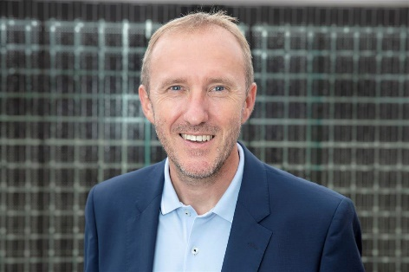
Martin Hackl, Global Director of the Business Unit Solar Energy, Fronius International GmbH

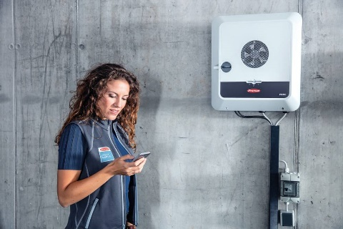
The popular Fronius GEN24 Plus hybrid inverter provides solutions in regard to photovoltaics, storage systems, backup power, heat, and e-mobility.

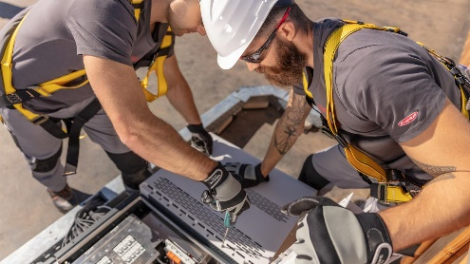
The Fronius Tauro project inverter offers maximum flexibility in terms of system design – with minimal overall system operating costs.

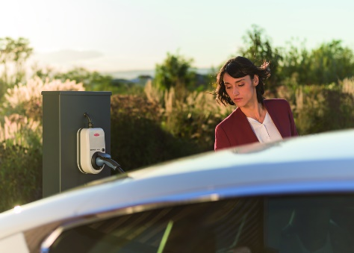
When it come to the Fronius Wattpilot, the focus will be on e-mobility in conjunction with photovoltaics, in particular cost-effective and sustainable PV surplus charging.

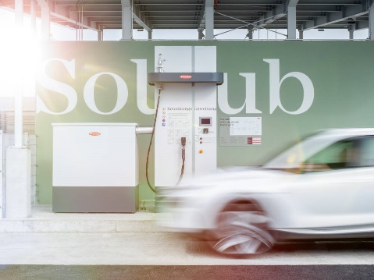
The second of Fronius’ own Solhub systems has recently been successfully commissioned in Steinhaus, Upper Austria.

Photos: Fronius International GmbH, reprint free of charge

About Fronius Solar Energy

The Fronius Business Unit (BU) Solar Energy has been developing photovoltaic energy solutions and distributing its products through a global network of expert installation, service and sales partners since 1992. More than 24 Solar Energy subsidiaries, an export ratio of over 93 percent and a total output of more than 21 Gigawatts from installed inverters are testament to this. Its mission is to achieve 24 hours of sun. Day after day Fronius is hard at work turning this vision of a future in which 100% of the world’s energy needs are covered by renewable sources into a reality. With this in mind, Fronius develops energy solutions to generate, store, distribute and consume solar energy economically and intelligently.

About Fronius International GmbH

Fronius International GmbH is an Austrian company with headquarters in Pettenbach and other sites in Wels, Thalheim, Steinhaus and Sattledt. With 5,660 employees worldwide, the company is active in the fields of welding technology, photovoltaics and battery charging technology. 92% of its products are exported through 36 international Fronius subsidiaries and sales partners/representatives in over 60 countries. With its innovative products and services and 1.321 granted patents, Fronius is the global innovation leader.

Enquiries:
Andrea SCHARTNER, +43 664 88536765, schartner.andrea@fronius.com, Froniusplatz 1, 4600 Wels, Austria.

Laura NACHBAUER, +43 664 677411572, nachbauer.laura@fronius.com, Froniusplatz 1, 4600 Wels, Austria.

Elfriede HIRSCH, +43 664 6213775, hirsch.elfriede@fronius.com, Froniusplatz 1, 4600 Wels, Austria.

Nicole FRIEDWAGNER, +43 664 88825931, friedwagner.nicole@fronius.com, Froniusplatz 1, 4600 Wels, Austria.

Copies:
a1kommunikation Schweizer GmbH, Rüdiger KEMPA, rke@a1kommunikation.de, Oberdorfstraße 31A, 70794 Filderstadt, Germany.

If you no longer want to receive press releases from Fronius International, Business Unit Solar Energy, please reply with UNSUBSCRIBE.

