Press release
Solar Energy

Energy Storage Inspection 2023

Fronius again earns top rankings

(Wels, 22 February 2023) Fronius has again achieved top rankings in the annual Energy Storage Inspection by the Berlin University of Applied Sciences (HTW), due to the company’s high system efficiency. The Fronius Primo GEN24 6.0 Plus earned top honors in the 5 kW reference case, as did the Fronius Symo GEN24 10.0 Plus in the 10 kW reference case. Fronius was also one of two manufacturers to again achieve energy efficiency class A with both products.

The Energy Storage Inspection by HTW Berlin is a study in which independent institutes perform an annual industry-wide comparison of photovoltaic storage systems for private households. This year, 18 energy storage systems from 11 manufacturers competed against each other and were evaluated using the System Performance Index (SPI). This independent assessment provides a good reference for installers and end customers searching for energy-efficient storage solutions. And the results are impressive: A system’s high efficiency means less energy loss, and that in turn leads to higher yields and therefore faster payback.
“We are bringing the sun into the lives of our customers. We demonstrated this once again in the Energy Storage Inspection. Fronius GEN24 Plus hybrid inverters perfectly transform our vision of 24 hours of sun into reality. They are the most efficient way to bring the sun from day into night and they make optimal use of available resources. This is essential for ensuring true sustainability. This outcome is the result of our continuous work on the life cycle assessment,” says Martin Hackl, Global Director of the Solar Energy Business Unit, Fronius International GmbH.

Results further improved
An SPI of 92.6 percent was achieved in the 5 kW reference case by the Primo GEN24 6.0 Plus together with the BYD Battery Box Premium HVS 7.7. In the 10 kW reference case, the Symo GEN24 10.0 Plus with the BYD Battery Box Premium HVS 10.2 achieved an SPI of 95.4 percent. “In both cases, we improved even further compared with last year,” Susanne Lampl, Product Manager, Fronius International, explains proudly.

Multi Flow Technology a success factor
One decisive success factor: Multi Flow Technology, which enables intelligent management of energy flows and not only allows simultaneous power flows in all directions but also AC and DC coupling of the storage battery. The basis for this is power electronics. Using silicon carbide-based power semiconductors enables very high conversion efficiencies to be achieved even at low loads of just a few hundred watts.

Words: 402
Characters: 2,503 (with spaces)

Overview image material

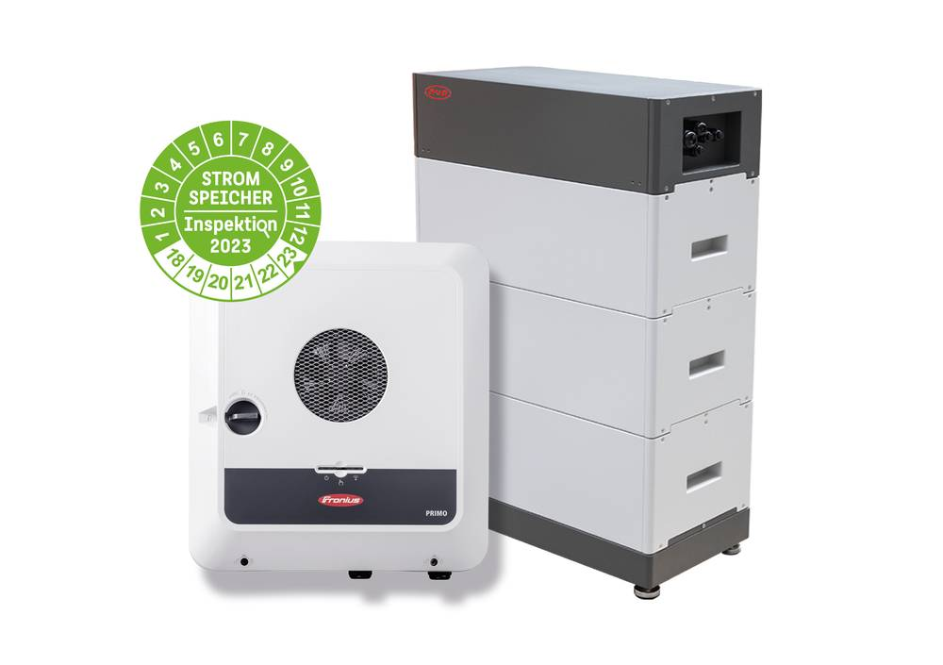

The high system efficiency leads to faster payback.


Martin Hackl, Global Director of the Business Unit Solar Energy, Fronius International GmbH



Susanne Lampl, Product Manager, Business Unit Solar Energy, Fronius International GmbH

Photo credits: Fronius International GmbH, reprint free of charge

Business Unit Solar Energy
Founded in 1992, the Fronius Business Unit (BU) Solar Energy is celebrating its 30th anniversary this year. Under the motto “Energize your life”, we develop innovative solutions with which solar energy can be generated, stored, distributed and consumed cost-efficiently and intelligently. Fronius Solar Energy makes it possible to use the sun 24 hours a day, paving the way for a future worth living in, in which renewable energies cover 100 percent of the world’s energy needs. Our solutions are sustainably developed and produced entirely in Europe – mainly in Austria. Fronius Solar Energy has 26 branches around the world and can point to a total output of more than 29 gigawatts of installed inverters to date. Sales are made via a global competence network of installation, service, and sales partners.
We are Fronius.
Over 6100 employees worldwide, a current export share of 89 percent, and 1366 active patents: that’s us, that’s Fronius. Founded in 1945 as a regional one-man operation, we are now a global player - a fact that is impressively demonstrated by our 37 international subsidiaries and our network of sales partners in more than 60 countries. And yet, at our core, we are still a family-owned company from Austria, active in photovoltaics, welding, and battery charging technology. We have always developed products and solutions for a future worth living, offering our customers an all-in-one package in the process: from advance planning and consulting to ongoing monitoring and a repair service tailored to their specific needs. We are innovative. We are curious. We are Fronius.

Enquiry note
Fronius International GmbH, Mag. Andrea SCHARTNER,
+43 664 88536765, schartner.andrea@fronius.com,
Froniusplatz 1, 4600 Wels, Austria
Laura NACHBAUER, +43 664 677411572, nachbauer.laura@fronius.com, Froniusplatz 1, 4600 Wels, Austria.

Elfriede HIRSCH, +43 664 6213775, hirsch.elfriede@fronius.com, Froniusplatz 1, 4600 Wels, Austria.

Specimen copy
a1kommunikation Schweizer GmbH, Rüdiger KEMPA,
rke@a1kommunikation.de
Oberdorfstraße 31A, 70794 Filderstadt, Germany

If you no longer wish to receive press releases from Fronius International GmbH (Business Unit Solar Energy) please reply with UNSUBSCRIBE to the e-mail address cancellation@fronius.com.

