Press release
Solar Energy

Storage unit inspection 2023

Top spots again for Fronius

(Wels, 07/03/2023) The high level of system efficiency of its devices was the reason why Fronius once again achieved top spots in the annual Energy Storage Inspection conducted by the University of Applied Sciences, Berlin. The Fronius Primo GEN24 6.0 Plus and the Fronius Symo GEN24 10.0 Plus were honoured in the 5 kW and 10 kW reference cases respectively. Fronius was again one of two manufacturers with two products boasting an energy efficiency rating of A.

The Energy Storage Inspection conducted by the university is a study carried out every year by independent institutions to compare photovoltaic storage systems for the private household sector. This year saw 18 energy storage systems from 11 manufacturers competing against each other to achieve the highest System Performance Index (SPI). This independent assessment provides installers and end customers with a useful yardstick when looking for an energy-efficient storage solution. And the results are impressive: the high efficiency of the system is indicative of low energy loss, which in turn results in higher yields and a shorter payback period.
“We bring sunshine into the lives of our customers and we were able to demonstrate this once again in the Energy Storage Inspection. Fronius GEN24 Plus hybrid inverters realise our vision of 24 hours of sun perfectly - bringing the power of the sun from day into night with the highest degree of efficiency and making the best use of available resources - something that is essential in order to guarantee true sustainability. This outcome is the result of our consistent work on the Life Cycle Assessment,” says Martin Hackl, Global Director of the Business Unit Solar Energy, Fronius International GmbH.

Results further improved
In the 5 kW reference case, the Primo GEN24 6.0 Plus together with the BYD Battery-Box Premium HVS 7.7 achieved an SPI of 92.6 percent, while in the 10 kW reference case, a Symo GEN24 10.0 Plus with a BYD Battery-Box Premium HVS 10.2 produced an SPI of 95.4 percent. “Both results are an improvement on last year’s excellent performance,” is the proud conclusion of Susanne Lampl, Product Manager, Fronius International.

Success down to Multi Flow Technology
Multi Flow Technology is a crucial factor behind this success. It enables the intelligent management of energy flows and not only permits simultaneous current flows in all directions, but also AC and DC coupling of the battery storage. At the heart of all this is power electronics. Very high conversion efficiency can be achieved through the use of silicon-carbide-based power semiconductors, even in the case of a low utilisation of several hundred watts.

You can find out more about the Energy Storage Inspection at:
https://solar.htw-berlin.de/studien/stromspeicher-inspektion-2023/

Words: 439
Characters: 2,771 (with spaces)

Images
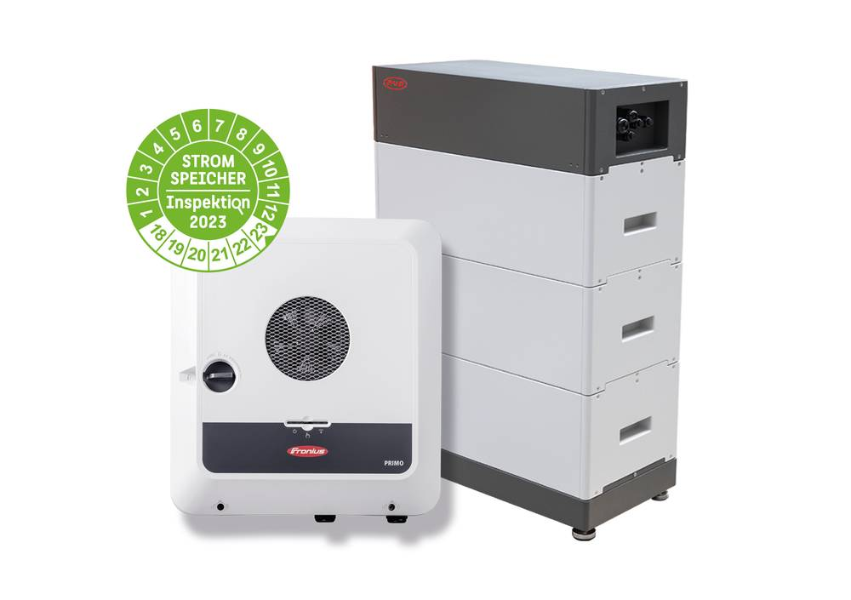
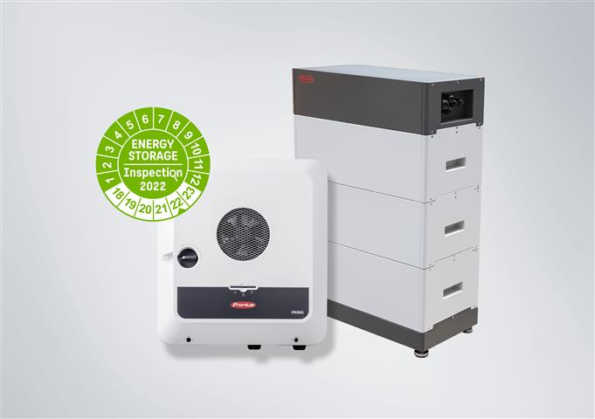

The high level of system efficiency results in a shorter payback period.


Martin Hackl, Global Director of the Business Unit Solar Energy, Fronius International GmbH.


Susanne Lampl, Product Manager, Business Unit Solar Energy, Fronius International GmbH.

Photo credits: Fronius International GmbH,

Business Unit Solar Energy
Founded in 1992, the Fronius Business Unit (BU) Solar Energy is celebrating its 30th anniversary this year. Under the motto “Energize your life”, we develop innovative solutions with which solar energy can be generated, stored, distributed and consumed cost-efficiently and intelligently. Fronius Solar Energy makes it possible to use 24 hours of sun every day, paving the way for a future worth living in, in which renewable energies cover 100 percent of the world’s energy needs. Our solutions are sustainably developed and produced entirely in Europe – mainly in Austria. Fronius Solar Energy has 26 branches around the world and can point to a total output of more than 29 gigawatts of installed inverters to date. Sales are made via a global competence network of installation, service, and sales partners.
We are Fronius.
Over 7000 employees worldwide, a current export share of 89 percent, and 1366 active patents: that’s us, that’s Fronius. Founded in 1945 as a regional one-man operation, we are now a global player - a fact that is impressively demonstrated by our 37 international subsidiaries and our network of sales partners in more than 60 countries. And yet, at our core, we are still a family-owned company from Austria, active in photovoltaics, welding, and battery charging technology. We have always developed products and solutions for a future worth living, offering our customers an all-in-one package in the process: from advance planning and consulting to ongoing monitoring and a repair service tailored to their specific needs. We are innovative. We are curious. We are Fronius.

Contact for further inquiries
Fronius International GmbH, Andrea SCHARTNER,
+43 664 88536765, schartner.andrea@fronius.com,
Froniusplatz 1, 4600 Wels, Austria
Natalie WOODFORD, +44 1908 512 301, woodford.natalie@fronius.com, Maidstone Road, Kingston, Milton Keynes, MK10 0BD, United Kingdom.

Kenny HO, +61 3 8340 2953, Ho.Kenny@fronius.com, 90-92 Lambeck Drive, Tullamarine VIC 3043, Australia.

Specimen copy
a1kommunikation Schweizer GmbH, Rüdiger KEMPA,
rke@a1kommunikation.de
Oberdorfstraße 31A, 70794 Filderstadt, Deutschland

If you no longer wish to receive press releases from Fronius International GmbH (Business Unit Solar Energy) please reply with UNSUBSCRIBE to the e-mail address cancellation@fronius.com.

