News release
Solar Energy

Fronius GEN24
Full solar power for the energy revolution
(Wels, 11/15 2023) Fronius ensures optimum safety and a high level of self-consumption for solar energy production with its high-quality inverters, and is now expanding its product portfolio with the Fronius GEN24.
The heart of any photovoltaic system is the inverter. It gets the most out of the sun and provides households with solar power in the best possible way for their individual needs. Building on the proven Fronius GEN24 Plus hybrid inverter, the Fronius GEN24 is the latest Fronius inverter for the home. At first glance, both products are almost identical in name, and boast the usual Fronius quality and specific features.
The new Fronius GEN24 impresses as a versatile inverter with an integrated basic backup power function, the PV Point. In the event of a power failure, a load such as a radio or cell phone charger, or even a small circuit up to 3 kW, can be supplied with single-phase power via a separate, protected outlet without any additional components being needed. This represents an important step toward independence from the public grid and energy self-sufficiency. “With the Fronius GEN24, our customers are less reliant on the public grid and also save a significant amount of money,” says Leonhard Peböck, Product Marketing Solar Energy at Fronius International GmbH. “Our inverter offers them the efficient solution of using the electricity from their own PV system themselves as long as the sun is shining. In times of volatile energy prices, this is a particular benefit of the GEN24.”
As a hybrid inverter, the tried-and-tested Fronius GEN24 Plus combined with a battery enables excess, self-generated solar power to be stored and consumed even during low-sun (nighttime) hours, bringing 24 hours of sun into the home. Thanks to the additional Full Backup option, the entire household and even large loads are still reliably supplied with electricity in the event of a power failure.
Convert to a hybrid inverter with a software upgrade
First the photovoltaic system, then a total energy solution: the Fronius GEN24 can become a hybrid inverter in no time at all, including the optional Full Backup option and the ability to connect to a battery storage system. All that’s needed is Fronius UP.storage—the innovative software upgrade from Fronius. It makes the Fronius GEN24 future-proof and thus a constant companion on the customer’s personal path to the energy transition.

Versatility as standard
Whether suspended, flat, or placed in a specific mounting bracket, and whether indoors or outdoors—the Fronius GEN24 is a real all-rounder, offering full design flexibility even under challenging conditions. “The inverter allows roof structures with different orientations or even small areas to be optimally used to produce energy. Thanks to the integrated shading algorithm—the Dynamic Peak Manager from Fronius—the highest yields are achieved even with partial shading,” Peböck continues.
Focus on sustainability
The Fronius GEN24 contains the well-known, impressive features of the Fronius inverters, such as the active cooling technology for continued high performance even at high ambient temperatures and the open system architecture, which makes it easy to integrate other components like home automation systems. In addition, individual components are easy to replace and service as needed. This keeps both the use of resources and the carbon footprint extremely low, impressively confirmed by the life cycle analysis (LCA) of the European-made sustainable Fronius inverter.
“Fronius is synonymous with holistic energy systems that boast the best carbon footprint. Our comprehensive and transparent product sustainability sets us apart from the competition. We are pioneers in the industry, both in terms of the level of detail and the consistency of the life cycle assessment. With the Fronius GEN24, we are once again able to support our customers with their personal energy transition in the best possible way,” says Martin Hackl, Global Director Marketing & Sales, Business Unit Solar Energy, Fronius International GmbH.

Words: 634
Characters: 4,043 (with spaces)

Images

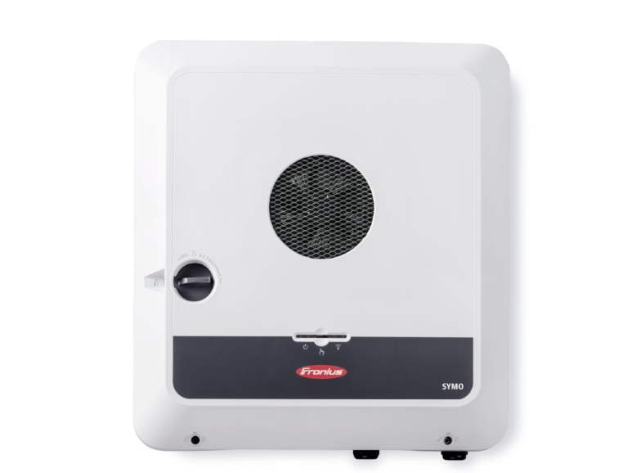 | The Fronius GEN24 inverter
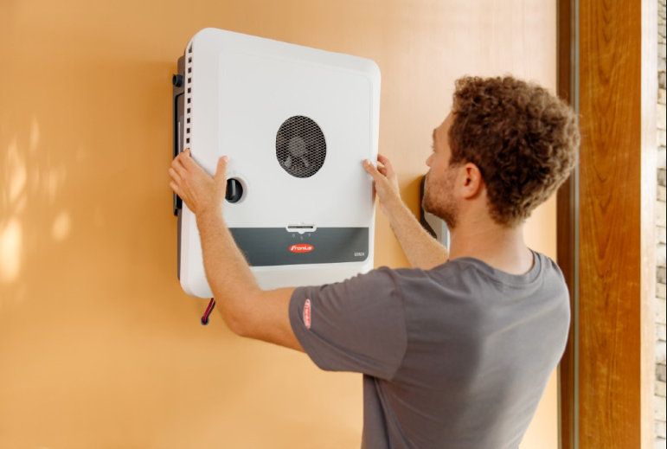 | The Fronius GEN24 product family offers flexible installation options.
 | The Fronius GEN24 product family impresses in terms of sustainability.

Photo credits: Fronius International GmbH; reprints free of charge

Business Unit Solar Energy
The Fronius Business Unit (BU) Solar Energy, which was founded in 1992, develops innovative solutions that generate, store, distribute and consume solar energy cost-efficiently and intelligently, all under the motto “energize your life”. Fronius Solar Energy makes it possible to use the sun 24 hours a day, paving the way for a future worth living in, in which renewable energies cover 100 percent of the world’s energy needs. Our solutions are sustainably developed and produced entirely in Europe – mainly in Austria. Fronius Solar Energy has 26 branches around the world and can point to a total output of more than 29 gigawatts of installed inverters to date. Sales are made via a global competence network of installation, service, and sales partners.
We are Fronius.
Over 8000 employees worldwide, a current export share of 87 percent, and 1446 active patents: that’s us, that’s Fronius. Founded in 1945 as a regional one-man operation, we are now a global player - a fact that is impressively demonstrated by our 37 international subsidiaries and our network of sales partners in more than 60 countries. And yet, at our core, we are still a family-owned company from Austria, active in photovoltaics, welding, and battery charging technology. We have always developed products and solutions for a future worth living, offering our customers an all-in-one package in the process: from advance planning and consulting to ongoing monitoring and a repair service tailored to their specific needs. We are innovative. We are curious. We are Fronius.

Enquiry note
Fronius International GmbH, Mag. Fabian SCHWARZ
+43 664 88536765, schwarz.fabian@fronius.com,
Froniusplatz 1, 4600 Wels, Austria
Specimen copy
a1kommunikation Schweizer GmbH, Rüdiger KEMPA,
rke@a1kommunikation.de
Oberdorfstraße 31A, 70794 Filderstadt, Germany

If you no longer wish to receive press releases from Fronius International GmbH (Business Unit Solar Energy) please reply with UNSUBSCRIBE to the e-mail address cancellation@fronius.com.

