News release
Solar Energy

Energy Storage Inspection 2024
Fronius Achieves Top Rankings for the Fifth Time

(Wels, 03/14/2024). Fronius achieved top rankings for the fifth time in a row at this year’s Energy Storage Inspection by Berlin University of Applied Sciences (HTW). The Fronius Primo GEN24 6.0 Plus with the BYD Battery-Box Premium HVS 7.7 and the Fronius Symo GEN24 10.0 Plus with the BYD Battery-Box Premium HVS 10.2 impressed the judges thanks to their high system efficiency.
Each year, as part of the Energy Storage Inspection run by Berlin University of Applied Sciences, independent testing institutes test the overall efficiency of storage systems and analyze the interaction of hybrid inverters and battery storage systems. Two different reference cases are used for the assessment. The first of these analyzes the SPI (System Performance Index) for a 5 kW photovoltaic system with an annual household consumption of 5,010 kWh/a. Here, the Fronius Primo GEN24 6.0 Plus, together with the BYD Battery-Box Premium HVS 7.7, achieved an SPI of 92.6%. The second reference case combines a 10 kW photovoltaic system with a heat pump (2,664 kWh/a), electric vehicle (1,690 kWh/a), and an annual household consumption of 5,010 kWh/a. The Fronius Symo GEN24 10.0 Plus and the BYD Battery-Box Premium HVS 10.2 achieved an SPI of 95.4%.
Independent Quality Indicator
“Every year, the Energy Storage Inspection by Berlin University of Applied Sciences is an important indicator for us and our customers. Through independent testing, it is evident that the combination of our hybrid inverter Fronius GEN24 Plus and the BYD Battery-Box Premium offers a highly efficient storage solution. This brings us one step closer to our goal of 24 hours of sun and a world with 100% renewable energy,” says Martin Hackl, Global Director Business Unit Solar Energy, Fronius International GmbH proudly.
Multi Flow Technology: Efficient and Flexible
In both reference cases, the Fronius inverters and BYD batteries are technically impressive across the board, both individually and combined. Fronius Multi Flow Technology enables the battery to be charged and loads in the household to be supplied from the PV system at the same time, even when running on backup power. Together, the two components are particularly impressive in terms of system efficiency, as well as high charging and discharging capacity.

Words: 359
Characters: 2.265 (including spaces)
Images
Photo credits: Fronius International GmbH; reprints free of charge
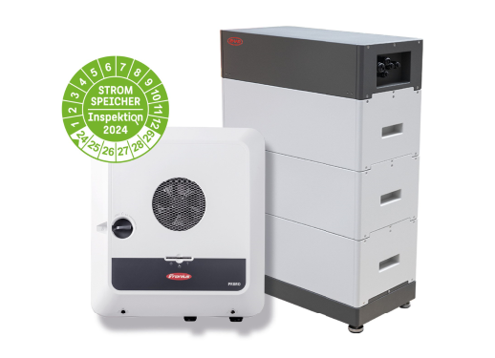 | The high system efficiency means a faster ROI.
 | Martin Hackl, Global Director of the Business Unit Solar Energy, Fronius International GmbH.

Business Unit Solar Energy
The Fronius Business Unit (BU) Solar Energy, which was founded in 1992, develops innovative solutions that generate, store, distribute and consume solar energy cost-efficiently and intelligently, all under the motto “energize your life”. Fronius Solar Energy makes it possible to use the sun 24 hours a day, paving the way for a future worth living in, in which renewable energies cover 100 percent of the world’s energy needs. Our solutions are sustainably developed and produced entirely in Europe – mainly in Austria. Fronius Solar Energy has 28 branches around the world and can point to a total output of more than 35 gigawatts of installed inverters to date. Sales are made via a global competence network of installation, service, and sales partners.
We are Fronius.
Over 8000 employees worldwide, a current export share of 87 percent, and 1446 active patents: that’s us, that’s Fronius. Founded in 1945 as a regional one-man operation, we are now a global player - a fact that is impressively demonstrated by our 37 international subsidiaries and our network of sales partners in more than 60 countries. And yet, at our core, we are still a family-owned company from Austria, active in photovoltaics, welding, and battery charging technology. We have always developed products and solutions for a future worth living, offering our customers an all-in-one package in the process: from advance planning and consulting to ongoing monitoring and a repair service tailored to their specific needs. We are innovative. We are curious. We are Fronius.

Enquiry note
Fronius International GmbH, Mag. Fabian SCHWARZ
+43 664 88536765, schwarz.fabian@fronius.com,
Froniusplatz 1, 4600 Wels, Austria
Specimen copy
a1kommunikation Schweizer GmbH, Rüdiger KEMPA,
rke@a1kommunikation.de
Oberdorfstraße 31A, 70794 Filderstadt, Germany

If you no longer wish to receive press releases from Fronius International GmbH (Business Unit Solar Energy) please reply with UNSUBSCRIBE to the e-mail address cancellation@fronius.com.

