Press release

30 years of Fronius Solar Energy

- From a sustainable vision to the largest business segment

- Photovoltaics boom leading to above-average growth

- Expansion of the Sattledt production site almost complete

(Wels/Sattledt, 07/07/2022) It was in the early 1990s that Fronius first decided to focus on solar energy as a “technology of the future”. Still not taken seriously back then, the business unit has come to represent the most important pillar of the family company. Since value creation is set to remain in Europe going forwards, this growth is mainly showing itself in the Sattledt production site in Upper Austria.
Fronius, the family-owned company based in Upper Austria, is often associated with the booming photovoltaics industry. But it wasn’t always this way: if you look back at the first 30 years of its youngest “Solar Energy” business unit, you’ll see that it was only in recent years that this branch developed into the company’s new driving force. For a long time, what was once the “technology of the future”, solar energy, led a shadowy existence and managed to survive one of the worst crises in company history. But one thing at a time…

The beginnings of Solar Energy
In 1950, Fronius began developing both its battery charging technology and welding technology branches, experiencing its first major successes from the 1960s onwards. These culminated in the milestone that was the introduction of an unprecedented welding system in 1981. “At some point we were starting to look more and more like power-guzzlers,”, remembers CEO Elisabeth Engelbrechtsmüller-Strauß. “You have to realise that, back then, welding technology required vast amounts of energy. We wanted to ‘give back’ some of this power and started the initial trials with photovoltaic modules. These were the beginnings of the Business Unit Solar Energy.”
Thirty years later it seems as though there’s no getting away from green power generation using solar energy. However, these current successes were nothing but a pipe dream for a very long time, as Engelbrechtsmüller-Strauß explains: “In the early days, we were often portrayed as tree-huggers and had great difficulty finding a place for our systems on the market. To put it into context, we used to manufacture just one to two inverters per week.”

Europe’s energy supply in focus
The extent to which things have since changed and the reason why the Solar Energy business unit has overtaken even the Business Unit Perfect Welding are underpinned by the latest figures: with a planned output of 510,000 inverters this year, Fronius is the biggest manufacturer of prosumer solutions in Europe. There are already 3.4 million Fronius inverters in operation around the world generating 35.1 TWh of clean solar energy every year – the equivalent of 33 Danube power plants. The energy supply is becoming increasingly decentralised as customers themselves become producers – they generate their own electricity, use it locally and pass the surplus on to other consumers. External environmental factors such as high energy prices and Europe’s future self-sufficiency are noticeably driving this development.
“The focus here is always on the huge relevance of European value creation. Particularly due to the recent supply bottlenecks, Europe is trying to reduce its dependence on other markets,” explains Martin Hackl, Global Director Marketing and Sales, Business Unit Solar Energy, Fronius International GmbH. “This absolutely warrants our support here at Fronius. Over many years, we’ve been successively reducing on European expertise in areas such as microelectronics. This puts us at a disadvantage compared with our Asian competitors but, that being said, we need to look at this development with a critical eye since we’re creating a sustainable and independent energy supply from products that don’t just come from other continents. For us, sustainable solutions are of the highest priority and the best way for us to make these is by expanding our manufacturing activities in Austria and the Czech Republic. As a result, we can guarantee the highest social, environmental and quality standards. In terms of transport routes, products from other continents are anything but practical and sustainable.”

The expansion in Sattledt in figures
That’s why Fronius has based its production sites in Austria and Czech Republic and has never been focused on outsourcing – quite the opposite in fact: “Strategically speaking, we’re preparing for major growth in Europe and investing heavily in expanding our production and capacities,” says Hackl. The best example is the major production and logistics site in Sattledt, Upper Austria. Here, the current usable space covering 41,000 m² is set to be expanded by an additional 28,000 m². Overall completion is already scheduled for late July 2022, after which the new space will gradually be filled.
The highlights of the so-called northward expansion include the fully automated high-bay warehouse. It will be the future transfer point for incoming goods and has room for 7,000 pallets and 12,500 small parts containers. Equally unique here are the two newly installed ice storage tanks, which currently constitute the biggest system of its kind in Europe. Put simply, an ice storage tank makes use of the crystallisation energy that is released when water turns to ice. With the aid of heat exchangers, this energy can be used for heating in winter and for cooling and air-conditioning the building in summer. And in line with the Fronius values, the new facility will soon be fully equipped with a photovoltaic system that increases the available 930 kWp by an additional megawatt peak of power.

The route out of the crisis
“We’re setting a number of examples with the new facility in Sattledt,” says Elisabeth Engelbrechtsmüller-Strauß. “Not only do we want to strengthen and secure the future of the site, but we also want to underscore our status as an employer with a stable future. Whereas others announced reduced working hours during the Covid-19 crisis, we launched our long-planned expansion. This year alone, we at Fronius are investing 187 million euros in the future. As a family business, we live and breathe continuity and are very forward-thinking. However, growth doesn’t come at any cost here, but rather only when we can afford it.”
This approach has served Fronius well in the past. For instance, precisely when Elisabeth Engelbrechtsmüller-Strauß took over as CEO, the company found itself in the midst of the solar crisis between 2011 and 2013. Back then, the principle of saving in good times to be ready for the bad proved its worth. “We invested the resources we had available into research and development, and thereby saved the business unit around ten years ago. A bank probably wouldn’t have given us access to these kinds of funds.”

Words: 1,064
Characters: 6,629 (incl. spaces)

Photographs – overview
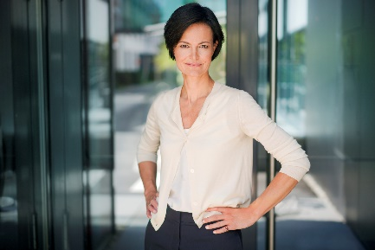

Fronius CEO Elisabeth Engelbrechtsmüller-Strauß

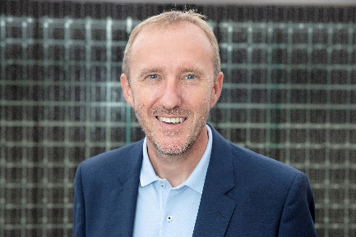

Martin Hackl, Global Director Marketing and Sales, Business Unit Solar Energy, Fronius International GmbH
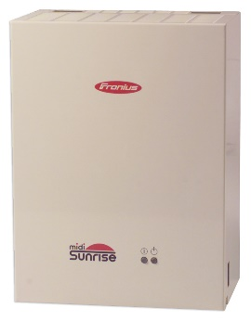

The “Sunrise” was the first inverter from Fronius.

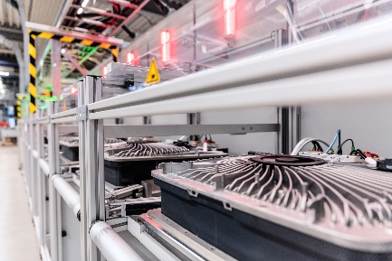

Inverter production in Sattledt

Photo credits: Fronius International GmbH, reproduction free of charge

Business Unit Solar Energy
The Fronius Solar Energy Business Unit (BU) founded in 1992 celebrates its 30th anniversary this year. Under the slogan “Energize your life”, we develop innovative solutions to enable solar energy to be generated, stored, distributed and used intelligently and cost-effectively. Fronius Solar Energy makes it possible to use 24 hours of sun pointing the way to a sustainable future in which renewable energy accounts for 100 percent of worldwide energy provision. Our solutions are developed and produced entirely in Europe with sustainability built into our processes – predominantly in Austria. Globally, Fronius Solar Energy is represented by 26 subsidiaries and to date can reference total output of more than 25 gigawatts from installed inverters. Its products are distributed through a global network of expert installation, service and sales partners.

About Fronius International GmbH
Fronius International GmbH is an Austrian family-owned company with its headquarters in Pettenbach and other sites in Wels, Thalheim, Steinhaus and Sattledt. From its beginnings as a regional one-man operation in 1945, Fronius has today developed into a global player with more than 5,660 employees worldwide and is active in the fields of welding technology, photovoltaics and battery charging systems. Its export ratio of 92 percent is achieved with 36 international Fronius companies and sales partners in more than 60 countries. With its innovative products and services as well as 1,321 active patents, Fronius is a world innovation leader.

Contact for further inquiries
Fronius International GmbH, Andrea SCHARTNER,
+43 664 88536765, schartner.andrea@fronius.com,
Froniusplatz 1, 4600 Wels, Austria
Natalie WOODFORD, +44 1908 512 301, woodford.natalie@fronius.com, Maidstone Road, Kingston, Milton Keynes, MK10 0BD, United Kingdom.

Kenny HO, +61 3 8340 2953, Ho.Kenny@fronius.com, 90-92 Lambeck Drive, Tullamarine VIC 3043, Australia.

Specimen copy
a1kommunikation Schweizer GmbH, Rüdiger KEMPA,
rke@a1kommunikation.de
Oberdorfstraße 31A, 70794 Filderstadt, Deutschland

If you no longer wish to receive press releases from Fronius International GmbH (Business Unit Solar Energy) please reply with UNSUBSCRIBE to the e-mail address cancellation@fronius.com.

.

