Press release

30 years of Fronius Solar Energy

- From a sustainable vision to the largest business segment

- Photovoltaics boom leading to above-average growth

- Expansion of the Sattledt production site almost complete

(Wels/Sattledt, 07/07/2022) It was in the early 1990s that Fronius first decided to focus on solar energy as a “technology of the future”. Still not taken seriously back then, the business segment has come to represent the most important pillar of the family company. Since value creation is set to remain in Europe going forwards, this growth is mainly showing itself in the Sattledt production site in Upper Austria.
Fronius, the family-owned company based in Upper Austria, is often associated with the booming photovoltaics industry. But it wasn’t always this way: if you look back at the first 30 years of its youngest “Solar Energy” business segment, you’ll see that it was only in recent years that this branch developed into the company’s new driving force. For a long time, what was once the “technology of the future”, solar energy, led a shadowy existence and managed to survive one of the worst crises in company history. But one thing at a time…

The beginnings of Solar Energy
In 1950, Fronius began developing both its battery charging technology and welding technology branches, experiencing its first major successes from the 1960s onwards. These culminated in the milestone that was the introduction of an unprecedented welding system in 1981. “At some point we were starting to look more and more like power-guzzlers,”, remembers CEO Elisabeth Engelbrechtsmüller-Strauß. “You have to realize that, back then, welding technology required vast amounts of energy. We wanted to ‘give back’ some of this power and started the initial trials with photovoltaic modules. These were the beginnings of the Business Unit Solar Energy.”
Thirty years later it seems as though there’s no getting away from green power generation using solar energy. However, these current successes were nothing but a pipe dream for a very long time, as Engelbrechtsmüller-Strauß explains: “In the early days, we were often portrayed as tree-huggers and had great difficulty finding a place for our systems on the market. To put it into context, we used to manufacture just one to two inverters per week.”

Europe’s energy supply in focus
The extent to which things have since changed and the reason why the Solar Energy business segment has overtaken even the Business Unit Perfect Welding are underpinned by the latest figures: with a planned output of 510,000 inverters this year, Fronius is the biggest manufacturer of prosumer solutions in Europe. There are already 3.4 million Fronius inverters in operation around the world generating 35.1 TWh of clean solar energy every year – the equivalent of 33 Danube power plants. The energy supply is becoming increasingly decentralized as customers themselves become producers – they generate their own electricity, use it locally, and pass the surplus on to other consumers. External environmental factors such as high energy prices and Europe’s future self-sufficiency are noticeably driving this development.
“The focus here is always on the huge relevance of European value creation. Particularly due to the recent supply bottlenecks, Europe is trying to reduce its dependence on other markets,” explains Martin Hackl, Global Director Marketing and Sales, Business Unit Solar Energy, Fronius International GmbH. “This absolutely warrants our support here at Fronius. Over many years, we’ve been successively expanding on European expertise in areas such as microelectronics. This puts us at a disadvantage compared with our Asian competitors but, that being said, we need to look at this development with a critical eye since we’re creating a sustainable and independent energy supply from products that don’t just come from other continents. For us, sustainable solutions are of the highest priority and the best way for us to make these is by bundling our manufacturing activities in Austria and the Czech Republic. As a result, we can guarantee the highest social, environmental, and quality standards. In terms of transport routes, products from other continents are anything but practical and sustainable.”

The expansion in Sattledt in figures
That’s why Fronius has based its production sites in Austria and Czech Republic and has never been focused on outsourcing – quite the opposite in fact: “Strategically speaking, we’re preparing for major growth in Europe and investing heavily in expanding our production and capacities,” says Hackl. The best example is the major production and logistics site in Sattledt, Upper Austria. Here, the current usable space covering 41,000 m² is set to be expanded by an additional 28,000 m². Overall completion is already scheduled for late July 2022, after which the new space will gradually be filled.
The highlights of the so-called northward expansion include the fully automated high-bay warehouse. It will be the future transfer point for incoming goods and has room for 7,000 pallets and 12,500 small parts containers. Equally unique here are the two newly installed ice storage tanks, which currently constitute the biggest system of its kind in Europe. Put simply, an ice storage tank makes use of the crystallization energy that is released when water turns to ice. With the aid of heat exchangers, this energy can be used for heating in winter and for cooling and air-conditioning the building in summer. And in line with the Fronius values, the new facility will soon be fully equipped with a photovoltaic system that increases the available 930 kWp by an additional megawatt peak of power.

The route out of the crisis
“We’re setting a number of examples with the new facility in Sattledt,” says Elisabeth Engelbrechtsmüller-Strauß. “Not only do we want to strengthen and secure the future of the site, but we also want to underscore our status as an employer with a stable future. Whereas others announced reduced working hours during the Covid-19 crisis, we launched our long-planned expansion. This year alone, we at Fronius are investing 187 million euros in the future. As a family business, we live and breathe continuity and are very forward-thinking. However, growth doesn’t come at any cost here, but rather only when we can afford it.”
This approach has served Fronius well in the past. For instance, precisely when Elisabeth Engelbrechtsmüller-Strauß took over as CEO, the company found itself in the midst of the solar crisis between 2011 and 2013. Back then, the principle of saving in good times to be ready for the bad proved its worth. “We invested the resources we had available into research and development, and thereby saved the business segment around ten years ago. A bank probably wouldn’t have given us access to these kinds of funds.”

Words:1,062
Characters: 6,615 (with spaces)

Overview images
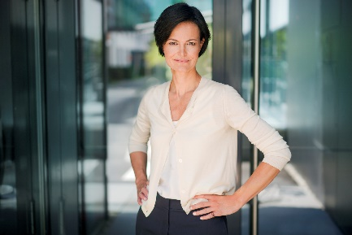

Fronius CEO Elisabeth Engelbrechtsmueller-Strauss

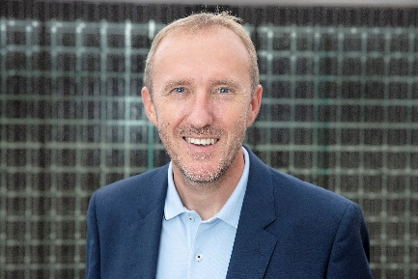

Martin Hackl, Global Director Marketing and Sales, Business Unit Solar Energy, Fronius International GmbH

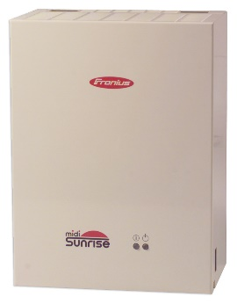

The “Sunrise” was the first inverter from Fronius.

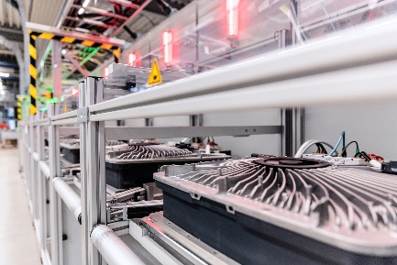

Inverter production in Sattledt

Photo credits: Fronius International GmbH, reproduction free of charge

Business Unit Solar Energy
Founded in 1992, the Fronius Business Unit (BU) Solar Energy is celebrating its 30th anniversary this year. Under the motto “Energize your life”, we’re developing innovative solutions designed to generate, store, distribute, and consume solar energy intelligently and cost effectively. Fronius Solar Energy makes it possible to use 24 hours of sun and is thereby pioneering a future worth living in, where renewable energy covers 100 percent of the world’s energy needs. Our solutions are sustainably developed and produced in Europe – mainly in Austria. Around the world, Fronius Solar Energy is represented by 26 subsidiaries and more than 25 gigawatts of installed inverter capacity. A global network of expert installation, service, and sales partners is responsible for distribution.

Über die Fronius International GmbH
Fronius International ist ein österreichisches Familienunternehmen mit Firmensitz in Pettenbach und weiteren Standorten in Wels, Thalheim, Steinhaus und Sattledt. 1945 als regionaler Einmannbetrieb gegründet, ist Fronius heute ein Global Player mit weltweit mehr als 5.660 Mitarbeiterinnen und Mitarbeitern, der in den Bereichen Schweißtechnik, Photovoltaik und Batterieladetechnik tätig ist. Der Exportanteil beträgt 92 Prozent und wird mit 36 internationalen Fronius-Gesellschaften sowie Vertriebspartnerinnen und -partnern in mehr als 60 Ländern erreicht. Mit innovativen Produkten und Dienstleistungen sowie 1.321 aktiven Patenten ist Fronius einer der Innovationsführer am Weltmarkt.

Enquiry note
Fronius International GmbH, Mag. Andrea SCHARTNER,
+43 664 88536765, schartner.andrea@fronius.com,
Froniusplatz 1, 4600 Wels, Austria
Laura NACHBAUER, +43 664 677411572, nachbauer.laura@fronius.com, Froniusplatz 1, 4600 Wels, Austria.

Elfriede HIRSCH, +43 664 6213775, hirsch.elfriede@fronius.com, Froniusplatz 1, 4600 Wels, Austria.

Specimen copy
a1kommunikation Schweizer GmbH, Rüdiger KEMPA,
rke@a1kommunikation.de
Oberdorfstraße 31A, 70794 Filderstadt, Germany

If you no longer wish to receive press releases from Fronius International GmbH (Business Unit Solar Energy) please reply with UNSUBSCRIBE to the e-mail address cancellation@fronius.com.

