News release
Solar Energy

Energy Storage Inspection 2022
Fronius achieves top rankings once again
(Wels, 04/25/2022) Fronius achieved top rankings for the third time in a row in the annual Energy Storage Inspection by the Berlin University of Applied Sciences (HTW). First place went to the Fronius Primo GEN24 6.0 Plus in the 5 kWp power class, while the Fronius Symo GEN24 10.0 Plus came in second in the 10 kWp power class. Fronius was also the only inverter manufacturer to achieve energy efficiency class A with both products.

The Energy Storage Inspection conducted by HTW Berlin is an industry-wide study carried out annually by independent institutes to compare photovoltaic storage systems for private households. This year, the competition saw 19 energy storage systems from 14 manufacturers go up against each other. They were evaluated with the System Performance Index (SPI), an independent evaluation method that provides a good reference for installers and end customers in their search for energy-efficient storage solutions. And the results are impressive: the system’s high efficiency means less energy is lost, which in turn leads to higher yields and consequently to a faster return on investment
“We bring sunshine into the lives of our customers and we were able to demonstrate this once again in the Energy Storage Inspection. This is the third time we’ve emerged as test winners. Fronius GEN24 Plus hybrid inverters realize our vision of 24 hours of sun perfectly - bringing the power of the sun from day into night with the highest degree of efficiency and making the best use of available resources - something that is essential in order to guarantee true sustainability. This outcome is the result of our consistent work on the Life Cycle Assessment,” says Martin Hackl, Global Director of the Business Unit Solar Energy, Fronius International GmbH.

The only manufacturer with energy efficiency class A in both power classes
The highest SPI in the 5 kWp power class was achieved by the Primo GEN24 6.0 Plus together with the BYD Battery-Box Premium HVS 7.7. Coming in at 92.2 percent, the PV storage system stands a full percentage point ahead of the runner-up. In the 10 kWp power class, the Symo GEN24 10.0 Plus with the BYD Battery-Box Premium HVS 10.2 achieved an SPI of 94.7 percent. “With the GEN24 Plus series, we were the only manufacturer to achieve energy efficiency class A in both power classes,” explains Susanne Lampl, Product Manager at Fronius International, with pride.

Success factors: Multi Flow Technology, silicon carbide, and strong partners
The Multi Flow Technology - a crucial success factor that enables the intelligent management of energy flows - not only permits simultaneous current flows in all directions, but also AC and DC coupling of the battery storage. The power electronics provide the basis for this. Very high conversion efficiency can be achieved through the use of silicon-carbide-based power semiconductors, even in the case of low utilization of several hundred watts.
Fronius has been working in strategic partnership with the Chinese high-tech company BYD for over four years now. The close cooperation with BYD began back in the development phase, enabling the two devices to be optimally matched to each other and resulting in high system efficiency.

All information about the Energy Storage Inspection can be found at: https://solar.htw-berlin.de/studien/speicher-inspektion-2022/

Words: 541
Characters: 3,395 (incl. spaces)

Images
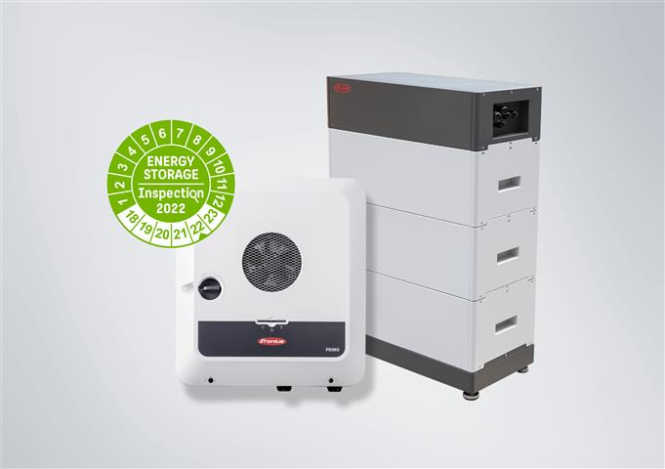
The high system efficiency means a faster ROI.

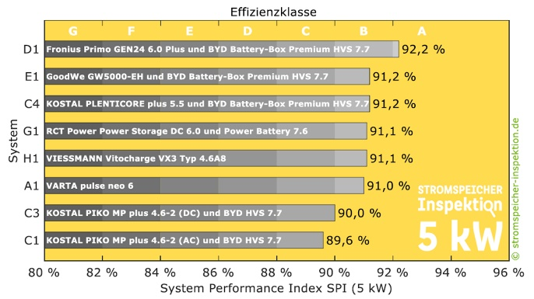

Fronius secures first place in the HTW Energy Storage Inspection for the third time in a row.


Martin Hackl, Global Director of the Business Unit Solar Energy, Fronius International GmbH.


Susanne Lampl, Product Manager, Business Unit Solar Energy, Fronius International GmbH.

Photo credits: Fronius International GmbH, reproduction free of charge

Business Unit Solar Energy
The Fronius Business Unit (BU) Solar Energy has been developing photovoltaic energy solutions and distributing its products through a global network of expert installation, service, and sales partners since 1992. Its 26 Solar Energy subsidiaries, an export ratio of over 89 percent, and a total output of more than 25 gigawatts from installed inverters are a testament to this. Its mission is to achieve 24 hours of sun. Day after day, Fronius is hard at work turning this vision of a future in which 100% of the world’s energy needs are covered by renewable sources into a reality. With this in mind, Fronius develops solutions to generate, store, distribute, and consume solar energy economically and intelligently.

About Fronius International GmbH
Fronius International GmbH is an Austrian family-owned company with its headquarters in Pettenbach and other sites in Wels, Thalheim, Steinhaus, and Sattledt. From its beginnings as a regional one-man operation in 1945, Fronius has today developed into a global player with more than 5,660 employees worldwide and is active in the fields of welding technology, photovoltaics, and battery charging systems. Its export ratio of 92 percent is achieved with 36 international Fronius companies, and sales partners in more than 60 countries. With its innovative products and services as well as 1,321 active patents, Fronius is a world innovation leader.

Contact for further inquiries
Fronius International GmbH, Andrea SCHARTNER,
+43 664 88536765, schartner.andrea@fronius.com,
Froniusplatz 1, 4600 Wels, Austria

Laura NACHBAUER, +43 664 677411572, nachbauer.laura@fronius.com, Froniusplatz 1, 4600 Wels, Austria.

Elfriede HIRSCH, +43 664 6213775, hirsch.elfriede@fronius.com, Froniusplatz 1, 4600 Wels, Austria.

Specimen copy
a1kommunikation Schweizer GmbH, Rüdiger KEMPA,
rke@a1kommunikation.de
Oberdorfstraße 31A, 70794 Filderstadt, Germany

If you no longer wish to receive press releases from Fronius International GmbH (Business Unit Solar Energy) please reply with UNSUBSCRIBE to the e-mail address cancellation@fronius.com.

