News release

Award

Fronius wins gold with EcoVadis rating

EcoVadis conducts sustainability ratings and is one of the world’s most well-known and renowned agencies. At this year’s evaluation, Fronius was awarded the gold medal for the first time, making it one of the top 5% most sustainable companies.
To date, the international rating agency EcoVadis has rated 100,000 companies in over 175 countries and from more than 200 industries. The four key areas of environment, labor and human rights, ethics, and sustainable procurement are closely scrutinized each year. The Upper Austrian family company Fronius was able to once again improve compared to the previous year—winning its first gold medal this time round, and placing Fronius in the top 5 percent of the most sustainable companies in the industry.
“We embody sustainability; you can sense it every day in our actions and our common commitment. Every contribution, no matter how small, lays a crucial foundation—for generations to come and for a future ​that we want to be proud of. Not only does the award from EcoVadis represent a huge step in the right direction, but it also serves as positive inspiration. We want to be even better, and so the journey goes on,” says Katrin Helmberger, Head of Corporate Sustainability.

Fronius phases out gas at production sites
In one of the biggest examples of a future-oriented sustainability strategy, the start of the year saw Fronius complete the phasing out of gas usage at all of its production sites in Austria, which have since been operating entirely free of fossil fuels. By investing in this gas phase-out, the company will be saving over 2.9 GWh of natural gas compared to the previous year at the Sattledt, Thalheim, Pettenbach, and Steinhaus sites alone. This equates to the gas consumption of roughly 73 homes, or 773 tons of CO₂ equivalent. Furthermore, the photovoltaic systems installed on the roofs currently already deliver an independent output of 4 MWp, while the purchased electricity is 100% certified green electricity.
Words: 325
Characters: 1,982 (with spaces)

Images
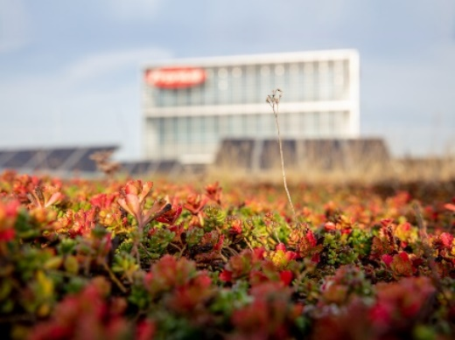

Fronius counts among the top 5% most sustainable companies.

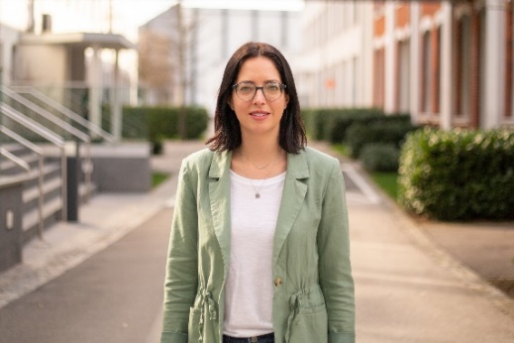

Katrin Helmberger, Head of Corporate Sustainability

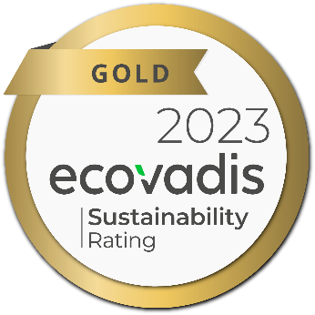

Fronius wins gold in the EcoVadis rating.

Copyright to photos: Fronius International GmbH, reproduction free of charge

We are Fronius.
Over 8,000 employees worldwide, a current export share of 87 percent, and 1446 active patents: that’s us, that’s Fronius. Founded in 1945 as a regional one-man operation, we are now a global player - a fact that is impressively demonstrated by our 37 international subsidiaries and our network of sales partners in more than 60 countries. And yet, at our core, we are still a family-owned company from Austria, active in photovoltaics, welding, and battery charging technology. We have always developed products and solutions for a future worth living, offering our customers an all-in-one package in the process: from advance planning and consulting to ongoing monitoring and a repair service tailored to their specific needs. We are innovative. We are curious. We are Fronius.

We are Perfect Charging.

Innovative charging solutions for efficient and sustainable charging of starter and traction batteries are our passion. We are Perfect Charging, the oldest business unit at Fronius with more than 75 years of experience in research and development. Together with our customers, we plan and implement intelligent indoor and outdoor charging solutions with a competitive edge. By doing so we make you save electricity, prolong your battery lifetime, and simplify your charging processes. Together we can make a change in reducing greenhouse gases and protecting the environment. Let’s contribute to a CO2-neutral intralogistics.

We are Perfect Welding.
Maximum arc quality, a deep understanding of our customers, a thirst for technical progress: this is what drives us at Fronius Perfect Welding. We are the innovation leader for arc welding and the global market leader for robot-assisted welding. Our customized, automated complete systems and digital welding solutions for Industry 5.0 are the product of our expertise. Intuitive welding systems for manual welding applications, high-quality welding accessories, and effective protective products to keep users safe round off our portfolio. As a global company, we offer regional service through local teams who are on hand for our customers around the world. Our technologies break new ground and form connections – between metals, industries, and people.

We are Solar Energy.
The Fronius Business Unit (BU) Solar Energy, which was founded in 1992, develops innovative solutions that generate, store, distribute and consume solar energy cost-efficiently and intelligently, all under the motto “energize your life”. Fronius Solar Energy makes it possible to use the sun 24 hours a day, paving the way for a future worth living in, in which renewable energies cover 100 percent of the world’s energy needs. Our solutions are sustainably developed and produced entirely in Europe – mainly in Austria. Fronius Solar Energy has 26 branches around the world and can point to a total output of more than 29 gigawatts of installed inverters to date. Sales are made via a global competence network of installation, service, and sales partners.

For more information, please contact:
Perfect Charging
Mrs. Sonja Pointner, Tel.: +43 664 621 38 98
E-Mail: pointner.sonja@fronius.com

Perfect Welding
Mrs. Heidemarie Haslbauer, Tel.: +43 664 882 93 709
E-Mail: haslbauer.heidemarie@fronius.com
Solar Energy
Mr. Fabian Schwarz, Tel.: +43 664 885 36 765
E-Mail: schwarz.fabian@fronius.com

Please send an author's copy to our agent:
a1kommunikation Schweizer GmbH, Mrs. Kirsten Ludwig,
Oberdorfstraße 31 A, 70794 Filderstadt, Deutschland
Tel.: +49 0 711 9454161-20,
E-mail: kirsten.ludwig@a1kommunikation.de

