PRESS RELEASE

Production management from your home office:

All welding data at a glance

Keeping track of welding production remotely is convenient, efficient, and sustainable. Digital tools such as the Fronius WeldCube Premium software are the key to achieving this.

Coronavirus is currently posing particular challenges to both society and businesses. Many companies are having to keep the number of workers physically present on their premises as low as possible, while striving to keep their businesses going as best they can. But can production managers, welding specialists, or maintenance managers also complete their tasks while working from home? Experience shows that it is possible if the required technical framework is in place. In automated series production for example, special software can be used to call up and analyze production data from welding systems. By accessing the company network, production can be controlled reliably and, if necessary, targeted measures taken even from an employee’s home.

Software solution for a mobile and flexible way of working

One company benefiting from the WeldCube Premium welding data management software is a European forestry machinery manufacturer. The company uses TPS/i welding systems from Fronius in its production processes. “With WeldCube Premium, welding data from networked Fronius devices are stored in a central database,” explains Johannes Zauner-Penninger, system engineer for software products at Fronius Perfect Welding. “The software provides intelligent management and statistical functions and enables component-specific documentation and analysis of the welding process. For example, in a live display, it shows whether a weld seam has already been welded or whether limit values have been violated,” adds Zauner-Penninger as he explains the functions of the software. Using a VPN connection, the customer can launch WeldCube Premium via an Internet browser from anywhere and at any time, giving them an overview of all welding processes in the networked production area.

For the current day-to-day life of manufacturers, this means that production managers, line managers, welding coordinators, and maintenance managers can work at least partly from home or without personal contact from an isolated office. Yet they can still provide the best-possible support to colleagues on site in the production area. If production personnel identify quality problems with a weld seam, they can forward the information to the responsible welding engineer. Not only does this engineer have an outline of the problem, they can also analyze the error immediately based on the data from the WeldCube Premium documentation. “What’s more, the welding system can be accessed directly via the Internet browser and, if necessary, parameters of the welding task can be remotely corrected,” says the Fronius system engineer.

WeldCube Premium: Central, component-based documentation

In addition, it is possible to track the degree of utilization of the machines and their status, the component progress, or any problems that occur. Central storage of the data enables them to be documented in relation to each component and PDF reports or graphs can be generated per component. Software solutions like WeldCube Premium therefore create a mobile and flexible way of working – whether from a home office, company premises, or while on business trips.

3,381 characters (including spaces)

[Navigation Title]
WeldCube Premium: Welding production at a glance

[Display name: URL]
weldcube-premium-homeoffice

[Meta Title]
Managing welding production from your home office with the WeldCube data software

[Meta Description]
Monitoring, managing, and, if necessary, adapting welding processes: WeldCube Premium from Fronius helps you keep an eye on welding data remotely.

Captions:

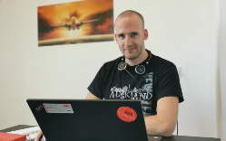
Image 1: The home office expert: Johannes Zauner-Penninger, from Global TechSupport Management Perfect Welding, looks after Fronius customers around the world when it comes to recording welding data and applications. This includes companies from all sectors looking for the perfect solution to networking their production processes.

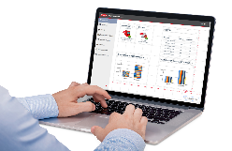
Image 2: In the WeldCube Premium data management software, users can customize the home page to suit their needs.

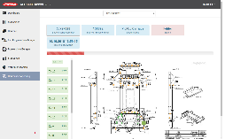
Image 3: The central storage of data from networked Fronius systems enables data to be documented in relation to each component.

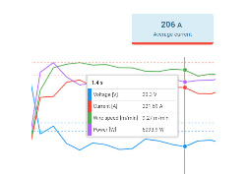
Image 4: Actual values per weld seam can be recorded and visualized at a sampling rate of up to 100 milliseconds.

Copyright to photos: Fronius International GmbH, reproduction free of charge

High-resolution images are available to download at the following link:
www.fronius.com/en/welding-technology/infocentre/press

Business Unit Perfect Welding
Fronius Perfect Welding is an innovation leader for arc welding and a global market leader for robot-assisted welding. As a systems provider, the Fronius Welding Automation division also implements customized automated complete welding solutions, for the construction of containers or offshore cladding for example. The range is rounded off by power sources for manual applications, welding accessories, and a broad spectrum of services. With more than 1000 sales partners worldwide, Fronius Perfect Welding has great customer proximity.

Fronius International GmbH
Fronius International is an Austrian company with headquarters in Pettenbach and other sites in Wels, Thalheim, Steinhaus and Sattledt. Founded by Günter Fronius in 1945, this long-standing company with a rich tradition will be celebrating its 75th anniversary in 2020. What began as a local one-man venture has grown into a global player with more than 5440 employees worldwide working in the areas of welding technology, photovoltaics and battery charging systems. Its export ratio of around 93 percent is achieved with 34 international Fronius subsidiaries and sales partners/representatives in more than 60 countries. Moreover, its innovative products and services and its portfolio of 1264 registered patents make it an innovation leader on the world market.

For more information, please contact:
Fronius Canada Ltd., Mr. Ted Clifford
2875 Argentia Road, Units 3 – 6 Mississauga, ON L5N 8G6
Tel.: +1 (905) 288 2128, E-Mail: Clifford.Ted@fronius.com

Please send an author's copy to our agent:
a1kommunikation Schweizer GmbH, FAO Kirsten Ludwig,
Oberdorfstraße 31 A, 70794 Filderstadt, Germany,
Tel.: +49 (0)711 9454161-20, e-mail: Kirsten.Ludwig@a1kommunikation.de

For more exciting updates, visit our blog at blog.perfectwelding.fronius.com and follow us on Facebook (froniuswelding), Twitter (froniusintweld), LinkedIn (perfect-welding), Instagram (froniuswelding) and YouTube (froniuswelding)!

