Press Release
Fronius UK – Perfect Welding

BSSA, Fronius UK and Cranfield University to Host Stainless Steel Welding Technology Event

The British Stainless Steel Association, in collaboration with Fronius UK and Cranfield University, is thrilled to present a dynamic and educational day of demonstrations and discussions focused on the art of joining stainless steel. This engaging event will be hosted at Fronius UK's state-of-the-art Milton Keynes Technology Centre on Thursday 3rd October. It is tailored for professionals working with stainless steel who are eager to discover best practices and cutting-edge technologies in stainless steel welding.
Stainless steel welding plays a crucial role in a wide array of industries such as aerospace, automotive, food and beverage, medical, and construction, where the material's durability, corrosion resistance, and aesthetic qualities are highly prized. The event will highlight pivotal advancements that are shaping the future of welding technology, including laser-hybrid, manual, and robotic welding. Attendees will gain insights into key considerations for welding stainless steel, such as selecting the appropriate type of stainless steel, pre-cleaning procedures, choosing the right filler materials, and controlling heat input to prevent warping and maintain corrosion resistance.
TIG welding has traditionally been favoured for joining stainless steel due to its superior control over the weld pool and its ability to produce aesthetically pleasing results. However, TIG is a slower process. Recent innovations in MIG welding are addressing heat input challenges and offering faster production times along with enhanced aesthetic outcomes. Switching to these innovative MIG processes could significantly optimize welding operations. Fronius UK is at the forefront of providing comprehensive solutions to the challenges associated with welding stainless steel.
In addition to the technical demonstrations, attendees will have the opportunity to hear from industry experts, learn from customer experiences, test products firsthand, and observe tangible results. The event also offers a valuable platform for networking with peers and industry leaders.
Throughout the day, attendees can listen to concise technical bulletins presented by experts from the BSSA, TVC Ltd, Cranfield University and Fronius. A detailed schedule with specific topics is available online for further reference.
Rob Cooper, Managing Director at the BSSA, remarked, "The BSSA is excited to be part of this unmissable opportunity to engage with leaders in stainless steel welding and explore the latest developments that can drive your business forward."
A hot lunch and refreshments will be provided throughout the day. If you are interested in exploring what this event has to offer, please register your intention to attend via Eventbrite so that we can accommodate all participants effectively.
For more information and to secure your spot, please visit: www.fronius.co.uk/BSSA-event.
2547 characters without spaces
This news release together with the images are available for you to download:
Photos: Fronius International GmbH; reprints free of charge
Photo material:

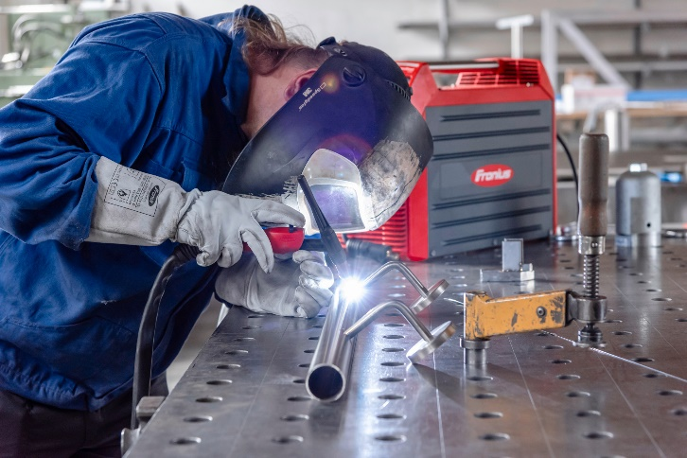
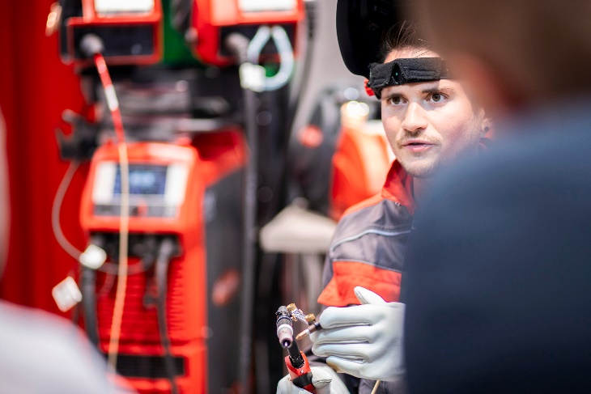
We are Fronius.
Over 8,000 employees worldwide, a current export share of 85 percent, and 1604 active patents: that’s us, that’s Fronius. Founded in 1945 as a regional one-man operation, we are now a global player - a fact that is impressively demonstrated by our 38 international subsidiaries and our network of sales partners in more than 60 countries. And yet, at our core, we are still a family-owned company from Austria, active in photovoltaics, welding, and battery charging technology. We have always developed products and solutions for a future worth living, offering our customers an all-in-one package in the process: from advance planning and consulting to ongoing monitoring and a repair service tailored to their specific needs. We are innovative. We are curious. We are Fronius.

We are Perfect Welding.
Maximum arc quality, a deep understanding of our customers, a thirst for technical progress: this is what drives us at Fronius Perfect Welding. We are the innovation leader for arc welding and the global market leader for robot-assisted welding. Our customized, automated complete systems and digital welding solutions for Industry 5.0 are the product of our expertise. Intuitive welding systems for manual welding applications, high-quality welding accessories, and effective protective products to keep users safe round off our portfolio. As a global company, we offer regional service through local teams who are on hand for our customers around the world. Our technologies break new ground and form connections – between metals, industries, and people.

For more information, please contact:
Fronius UK Ltd; Miss Kim Lee;
Maidstone Road, Kingston, Milton Keynes, MK10 0BD
Phone: +44 1908 512340
E-Mail: lee.kim@fronius.com

