PRESS RELEASE

Prototyping centre
Be it complex welding challenges, feasibility studies or small-scale production – Fronius has the solution

Developing individual solutions for challenging welding tasks? This is where Fronius comes in, supporting industrial and commercial enterprises at its prototyping centre in Wels, Austria. Whether the focus is on feasibility studies, welding prototypes, pre-production series or contract manufacturing for small series, the customer benefits from the Fronius experts’ comprehensive welding knowledge and their deadline pressure and investment risk are reduced.

Companies that want to take advantage of new trends or tap into fresh market segments are forced to leave their comfort zone because they need innovative materials and components, and set new challenges for themselves in production. A big issue here is the development and construction of prototypes. This can involve large investments, including in systems, software and staff, which come with a certain level of uncertainty. To reduce risks and costs, Fronius provides companies with the option to permanently outsource the welding-relevant parts of their prototype construction. In the Fronius prototyping centre, which covers a total area of more than 900 square metres, specialists from Fronius develop customised solutions to tackle every welding challenge.

“Since we put the Fronius prototyping centre into operation in early 2021, we have developed solutions to meet a wide range of requirements for customers from various sectors,” emphasises Wolfgang Scherleitner, head of the prototyping centre. “However, we don’t just offer technical support. Instead, we have expanded our range of services to include a number of high-tech analyses and simulations. This enables us to guarantee high quality as well as seamless welding data documentation.”

To make this possible, the prototyping centre offers a range of services including 3D equipment fabrication, 3D measurement and an offline programming option complete with welding process simulation. But not only that, heat and distortion simulation, welding seam inspection, a laser seam-tracking camera, hot active plasma technology for surface cleaning and a laboratory for metallographic examination all come as standard too. With the pioneering WeldCube software – for documenting and analysing welding data – Fronius makes it possible to trace the entire component history in detail. What is more, the welding technology specialists attach great importance to economical, resource-conserving and efficient production right from the outset.

The Fronius prototyping centre offers considerable added value particularly when it comes to strict quality requirements and more efficient production methods. Large dimensions, complex designs, tight deadlines and brand-new products – which call for particularly intelligent welding concepts – are all covered here and considered a matter of course. The welding experts are also available to support the transition from manual to robotic welding as well as the application of new materials or welding processes.

Customers from a wide range of sectors, including the automotive and component supply industries, aerospace technology, the agricultural and construction machinery industries and commercial transport, have already taken advantage of these services. Be it battery trays for e-mobility, axles, frame sections or various applications for other industrial sectors, parts of up to 1,500 kg and 3 x 2 metres can all be joined in the prototyping centre – and all with one technology that sets standards around the world for simulation, process monitoring and quality control.

3,134 characters incl. spaces

Copyright to photos: Fronius International GmbH, reproduction free of charge

High-resolution images are available to download at the following link:
www.fronius.com/en/welding-technology/infocentre/press

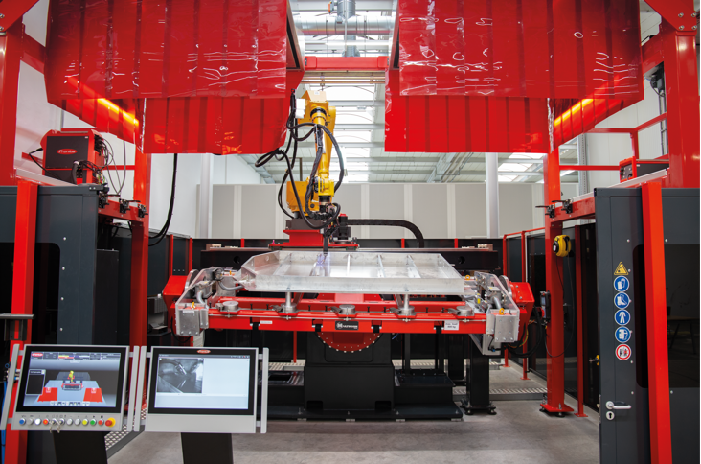

Photo 1: The robot welding cell features high-tech process variants from Fronius – such as Cold Metal Transfer (CMT), Pulse Multi Control (PMC) and Low Spatter Control (LSC). It also includes ACERIOS, a hot active plasma technology for surface cleaning.

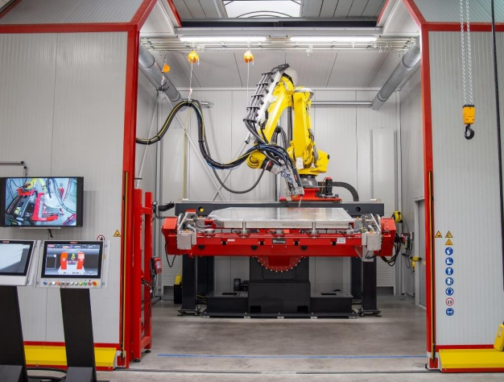
Photo 2: The LaserHybrid cell combines a powerful gas metal arc welding system (GMAW) with state-of-the-art laser technology. This makes it possible to weld components made of different materials to a high quality – with minimal distortion – at speeds of up to 8 m/min.
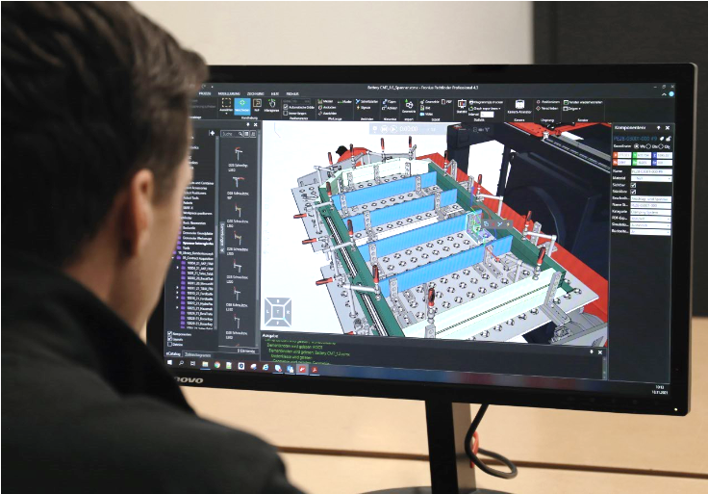
Photo 3: The Pathfinder simulation software provides cycle-time analyses and a realistic representation of complete processes as early as the pre-project stage. Optimisations can therefore be implemented early on, minimising the time and expenses involved here.

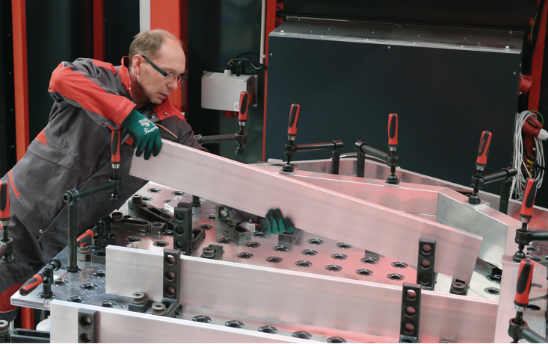
Photo 4: Flexible, modular 3D clamping systems are available for prototype equipment fabrication. It is also possible to simulate all clamping components virtually.

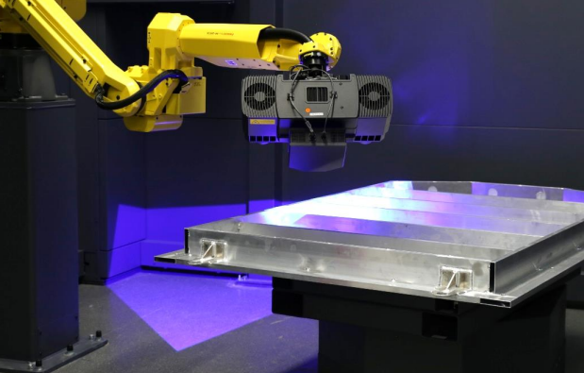
Photo 5: The optical 3D measuring system with high definition camera detects the slightest deviations and component distortion.

Link: Prototyping centre at Fronius
Blog: Outsourcing prototype welding and freeing up more resources for innovations

Business Unit Perfect Welding
Fronius Perfect Welding is the innovation leader for arc welding and is the global market leader for robot assisted welding. As system providers, Fronius Welding Automation also turns customer-specific automated complete welding solutions into reality in a number of areas, from container construction right up to cladding for the offshore sector. Power sources for manual applications, welding accessories and a wide range of services add to our portfolio. With more than 1,000 sales partners worldwide, Fronius Perfect Welding is never far away from our customers.

Fronius International GmbH
Fronius International GmbH is an Austrian company with headquarters in Pettenbach and other sites in Wels, Thalheim, Steinhaus and Sattledt. With 5,660 employees worldwide, the company is active in the fields of welding technology, photovoltaics and battery charging technology. 92% of its products are exported through 36 international Fronius subsidiaries and sales partners/representatives in over 60 countries. With its innovative products and services and 1,321 granted patents, Fronius is the global innovation leader.

Contact details for publishing:
Fronius UK Ltd
+44 1908 512300
info-uk@fronius.com
www.fronius.co.uk

For more information, please contact:
Fronius UK Ltd; Miss Kim Lee;
Maidstone Road, Kingston, Milton Keynes, MK10 0BD
Phone: +44 1908 512340
E-Mail: lee.kim@fronius.com

Please send a specimen copy to our agency:
a1kommunikation Schweizer GmbH, Kirsten Ludwig,
Oberdorfstraße 31 A, 70794 Filderstadt, Germany
Phone: +49 0 711 9454161-20
E-Mail: kirsten.ludwig@a1kommunikation.de

For more exciting updates, visit our blog at blog.perfectwelding.fronius.com and follow us on Facebook (froniuswelding), Twitter (froniusintweld), LinkedIn (perfect-welding), Instagram (froniuswelding) and YouTube (froniuswelding)!

