Press RELEASE

From the feasibility study to small series production:

Fronius opens a new prototyping center

The demand for electric cars is constantly increasing. New types of components are therefore necessary and their production must be perfected. For example, battery trays protect the sensitive batteries from external influences – even in the event of a crash. However, there are few welding processes that are suitable for joining the aluminum components used solidly and with low levels of distortion. Thanks to its new prototyping center, Fronius is the specialist for this and other similar applications.

From the beginning of December, Fronius will be offering car manufacturers, their suppliers, and integrators the option to outsource prototype construction. In the new prototyping center in Wels (Upper Austria), Fronius welding technology specialists will work with customers to develop the ideal solution for joining their components, starting with the design phase, feasibility studies using simulations, welding process evaluation and welding trials, through to various quality checks and project support. In addition to prototype production with all its various phases, Fronius also manufactures smaller quantities of customer components for pre-series production if required. Fronius therefore offers a complete solution for prototype construction.

As a result, car manufacturers can benefit from considerable savings potential, increased efficiency, and minimization of risks. By outsourcing the production of prototypes, development costs, time-intensive labor, and investments in dedicated prototyping centers are eliminated. What’s more, customers benefit from Fronius’ extensive welding expertise and the associated state-of-the-art technologies.

Premium welding technology for prototype construction

Covering more than 900 square meters, the prototyping center provides sophisticated simulation, welding, and measuring technology. This makes it possible to manufacture components measuring up to 3x2 meters and weighing up to 1,500 kilograms. The facilities are sealed off from other areas and guarantee absolute discretion.

One of the two robot welding cells used is equipped with Fronius CMT technology. The heat-reduced welding process is suitable for almost any parent material, especially light-gage sheet metal, and reduces spattering and distortion. The flexible TPS/i welding system platform used for this purpose also allows other welding processes to be employed if required. In addition, the robot cell uses an Acerios surface cleaning system that pre-treats the edges of the components using hot plasma technology. This creates the perfect conditions for high-quality welding seams.

The second robot welding cell features both a laser and a powerful GMAW welding system. In conjunction, the LaserHybrid process combines the advantages of both worlds and thus offers excellent gap-bridging ability and high welding speeds. Deep penetration and low heat input – and thus minimal component distortion – also go hand in hand here.

Sensor technology, measurement, and data documentation

Both welding cells are equipped with sophisticated robot assistance and control systems:

- A laser monitoring system mounted on the welding torch ensures that the robot welds in exactly the right location. In case of misalignment, distortion, or tolerances that are common in production, the robot can automatically correct the pre-programmed weld seam path and welding is performed reliably at the correct position.
- Fronius SeamTracking provides another option: This function reliably detects the component edge through welding torch pendulum movements for fillet and prepared butt welds.
- In addition, the ArcView camera system provides a direct view of the arc, enabling the welding process to be monitored precisely. If necessary, the welder can immediately take corrective action.
- What’s more, an automated weld seam inspection system scans the seam after the welding process and immediately performs a visual quality inspection.
- At the same time, the WeldCube data documentation software monitors and stores all relevant data from the welding process and enables clear traceability of each seam.

In addition to highly developed welding processes and the monitoring of these processes, the component is measured three-dimensionally in a dedicated robot cell after welding, which allows any deviations such as tolerances or distortion to be accurately detected. This precise monitoring of the exact dimensions thus takes place from an early stage in the prototype construction, enabling a quick response and adjustment of various parameters (e.g., welding sequence, welding parameters, and clamping technology) and saving time and costs both during development and in the subsequent production ramp-up. Fronius also offers its customers the option of subjecting the prototypes to metallurgical testing in the laboratory.

4,935 characters (including spaces)

Navigation title: Grand opening: New prototyping center
Display name: prototyping-center
Meta title: Fronius welds prototypes, e.g., for battery trays
Meta description: From the feasibility study to small series production, Fronius gives car manufacturers and suppliers the option to outsource prototype construction.

Captions:

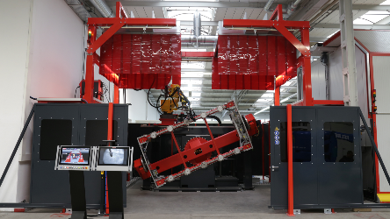
Image 1: The robot welding cells in the Fronius prototyping center are equipped with the latest clamping, sensor, and welding technology – such as the CMT process.

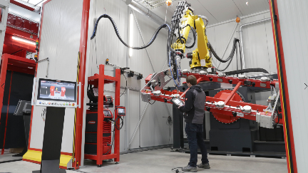
Image 2: The LaserHybrid process ensures fast, reliable seams with low levels of distortion – especially for large components such as battery trays.

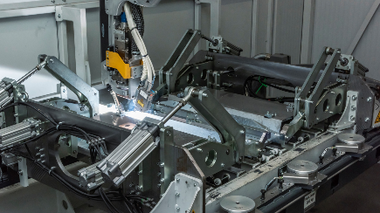
Image 3: Battery trays protect the batteries of electric cars from environmental influences or even in the event of a crash – the demands on the welding seams are therefore high. Thanks to the new prototyping center, Fronius is the specialist for these and similar innovative components.

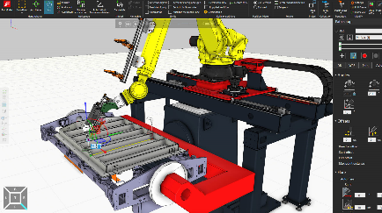
Image 4: The simulation software enables cycle times to be determined and accessibility to be checked for the feasibility study, as well as offline programming.

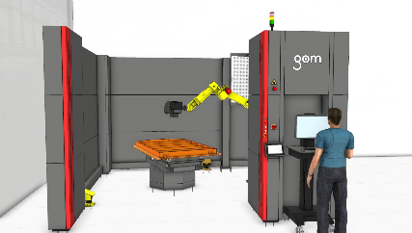
Image 5: After welding, the component is checked in the measuring cell (computer rendering).

Photos: Fronius International GmbH, reproduction free of charge

This press release and the images can be downloaded from:
www.fronius.com/en/welding-technology/info-centre/press/prototyping-center

Business Unit Perfect Welding
Fronius Perfect Welding is an innovation leader for arc welding and a global market leader for robot-assisted welding. As a systems provider, the Fronius Welding Automation division also implements customized automated complete welding solutions, for the construction of containers or offshore cladding for example. The range is rounded off by power sources for manual applications, welding accessories, and a broad spectrum of services. With more than 1000 sales partners worldwide, Fronius Perfect Welding has great customer proximity.

Fronius International GmbH
Fronius International is an Austrian company with headquarters in Pettenbach and other sites in Wels, Thalheim, Steinhaus and Sattledt. Founded by Günter Fronius in 1945, this long-standing company with a rich tradition will be celebrating its 75th anniversary in 2020. What began as a local one-man venture has grown into a global player with more than 5440 employees worldwide working in the areas of welding technology, photovoltaics and battery charging systems. Its export ratio of around 93 percent is achieved with 34 international Fronius subsidiaries and sales partners/representatives in more than 60 countries. Moreover, its innovative products and services and its portfolio of 1264 registered patents make it an innovation leader on the world market.

For more information, please contact:
Fronius Canada Ltd., Mr. Ted Clifford
2875 Argentia Road, Units 3 – 6 Mississauga, ON L5N 8G6
Tel.: +1 (905) 288 2128, E-Mail: Clifford.Ted@fronius.com

Please send an author's copy to our agent:
a1kommunikation Schweizer GmbH, FAO Kirsten Ludwig,
Oberdorfstraße 31 A, 70794 Filderstadt, Germany,
Tel.: +49 (0)711 9454161-20, e-mail: Kirsten.Ludwig@a1kommunikation.de

For more exciting updates, visit our blog at blog.perfectwelding.fronius.com and follow us on Facebook (froniuswelding), Twitter (froniusintweld), LinkedIn (perfect-welding), Instagram (froniuswelding) and YouTube (froniuswelding)!

