News release
Perfect Welding

Fronius Outlook 2023
Successful use of potential
With double-digit sales growth, 2022 was the best year in the history of Fronius Perfect Welding, despite the extremely challenging conditions. In 2023, Fronius would like to continue growing in the welding technology sector. In addition to the enormous expansion of manufacturing capacities for welding systems and torches, Fronius’ focus for 2023 will be on solutions to alleviate the shortage of skilled workers, as well as on energy and resource-conserving technologies.
For Fronius Perfect Welding, 2022 was characterized by strong growth and a series of trend-setting innovations. Both of these put us in a good starting position to face the new year with confidence and trust in our own innovative strength. “In our research and development work, we proactively respond to the constantly changing market requirements. We put ourselves in our customers' shoes and try to offer the best possible solutions for their challenges,” explains Harald Scherleitner, Global Director of Sales and Marketing, Business Unit Perfect Welding, Fronius International GmbH. “We develop highly user-friendly, top-quality devices that can be used flexibly and expanded as required. The idea of sustainability plays an important role in every step of product development. We pay attention to the longevity, repairability, and recyclability of our welding systems.”
Technical Highlights of 2022
Determined to achieve these objectives, Fronius introduced several pioneering innovations to the market last year. An undisputed industry highlight was the market launch of the new iWave Multiprocess PRO. Whether for TIG, MIG/MAG or manual metal arc welding, this 3-in-1 system saves companies from having to buy several different pieces of equipment, which saves money and natural resources. Regarding the increasing shortage of skilled workers, another world first followed in the form of Fronius’ “TIG DynamicWire” welding package and the appropriate cold wire components for the iWave. All of this makes it easy—even for beginners without years of training—to achieve high-quality TIG seams with a wire feeder.
Since 2022, Fronius’ aims have been: to reduce the workload of skilled workers, to deploy these workers optimally, and to protect them. With the Fronius CWC-S Cobot welding cell, the step towards automation proves profitable from batch size 1, and therefore also for small and medium-sized companies. While the CWC-S works around the clock to weld components with consistent quality, welders are able to devote more time to more demanding tasks, and are optimally protected by Fronius equipment such as the Fronius Vizor Air/3X respiratory protection system and the Vizor Air/3X Connect fresh air helmet. The brand-new mobile Exento extraction systems and Exento fume extraction welding torch offer excellent protection from welding fumes for welders and everyone working in their vicinity.
Cleanliness is essential when it comes to high welding quality. That is why Fronius has developed environmentally-friendly cleaning processes. The fully automatic Acerios cleaning system sets new standards in the industrial manufacturing process. Based on hot-active plasma technology, it impresses with its low energy consumption and high level of efficiency, and does not contain any environmentally harmful cleaning additives. For the manual cleaning of stainless steel surfaces and TIG weld seams, Fronius has unveiled the latest generation of the MagicCleaner. This advanced series cleans quickly, effectively, and in an environmentally-friendly manner.
As a joining technology specialist, Fronius is passionate about arc-related innovations. That's why customers can look forward to many more innovations in 2023.
Welding Trends for 2023: Sustainability Is Still at the Center of Attention
In 2023, hot topics for the welding industry will primarily be the shortage of skilled workers, sustainability, and fully exploiting the potential offered by digitalization and automation.
Fronius has a comprehensive understanding of sustainability and its ecological, social, and economic aspects, and has established a strategic management system in the field of corporate social responsibility, pursuant to ISO 26000 (ONR 192500 certified). The interest shown by customers also reflects how sustainability awareness is on the rise in trade and industry. That is why the company regularly undergoes evidence-based sustainability assessments, which are carried out by objective third parties such as EcoVadis or the NQC Supplier Assurance Platform. In 2022, Fronius was awarded EcoVadis Silver status for the first time, which means that it can now proudly count itself among the top 25 percent in the industry.
2023: Investments and Innovations
In 2022, Fronius invested €187 million in the expansion and conversion of manufacturing sites. In 2023, its total investments will increase to more than €233 million. The usable area of the Sattledt site was expanded from 41,000 m² to 69,000 m² and is already gradually being put into operation. “Among other things, we are creating space for additional workstations and production lines for systems equipment and ensuring a stable manufacturing situation. We are hoping to take on around 1,300 new employees internationally by the end of 2023. A lot will also happen at the Pettenbach site in 2023—for example, additional capacities for welding torch manufacturing will be created there,” reports Harald Scherleitner. High added value in Europe is the top priority for Fronius, in order to guarantee high quality and safety standards. In addition, self-supply with energy from renewable sources is being continuously expanded.
The welding portfolio is being expanded to include several technical solutions to help counteract the shortage of skilled workers. Fronius is relying here on the comprehensive digitalization of all processes and on intuitive, user-friendly systems and applications. These will help employees to get up and running more quickly and to carry out demanding, high-quality welding processes. Overall, Fronius sees digital solutions as the key to increasing the efficiency and quality of welding processes.
Standardized Welding Processes with the WeldCube Navigator
In 2023, Fronius is set to launch the WeldCube Navigator, a digital tool that will standardize work instructions in a new way and simplify knowledge transfer. A predefined step-by-step guide on the display will guide welders through their tasks. This will not only improve the welding quality, but the WeldCube Navigator will also make familiarization and training easier and faster.
The Welducation Simulator: Realistic Welding Training Like Never Before
Fronius’ virtual welding training does not use any material, reduces costs, and has been successfully used for years. With the new Welducation Simulator, which is set to be launched in the fall, Fronius will take this form of welding training to a new level. Packaged in a standard welding torch housing, with real torches and a realistic representation in augmented reality (AR), the Welducation Campus platform that comes with the simulator will offer comprehensive quality welding training with theory, welding tasks and knowledge testing.
Dual Wire Feeder: Two Welding Torches, Two Wirespools, One TPS/i
In addition to digital innovations, Fronius will introduce new hardware solutions in 2023. The Dual Wire Feeder is a double wire feed for the Fronius TPS/I series. Equipped with two wire rollers and two hose or burner packs, the welder can easily and very quickly switch between two wire thicknesses or materials with the dual wire feeder.
Trade Fairs, Events, and Conferences
If you would like to meet Fronius’ joining experts in person or see our latest innovations for yourself, why not attend one of the company’s 135+ events, trade fairs, or conferences, which have been scheduled in various locations worldwide throughout 2023? Don’t forget to look out for members of the Fronius team at the Schweissen & Schneiden trade fair in Essen and Fabtech in Chicago. On May 10 and 11, Fronius will also be hosting the seventh “Joining Smart Technologies” automotive conference, which this year will focus on the topics of sustainability and digitalization. We’re looking forward to seeing you there!
Joining Smart Technologies automotive conference:
EN: Joining Smart Technologies 2023 (joining-smart-technologies.com)
7.071 characters excluding spaces
This news release and the images can be downloaded from: https://www.fronius.com/en/welding-technology/info-centre/press
Copyright to photos: Fronius International GmbH, reproduction free of charge

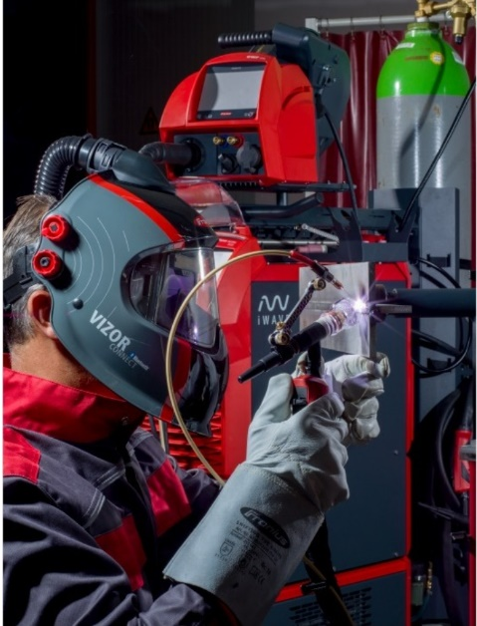

Launched in 2022, the iWave Multiprocess PRO is Fronius’ intelligent 3-in-1 high-end series for TIG, MIG/MAG and manual metal arc welding. It can be individually tailored to the customer’s requirements, and with the right TIG DynamicWire welding package, the supreme discipline—TIG cold wire welding—becomes child's play.

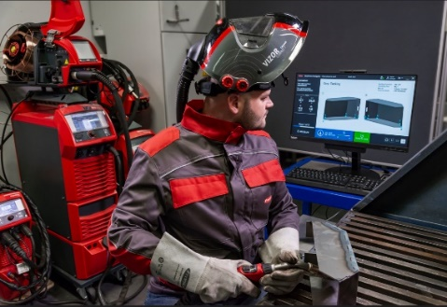
With step-by-step instructions, the WeldCube Navigator guides welders through tasks using the respective component. This makes training easier and ensures high quality.

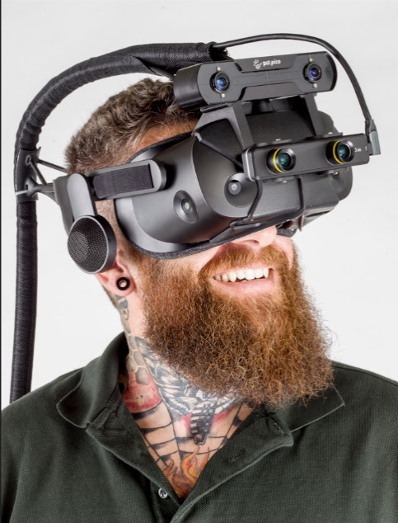
The new Welducation simulator takes virtual welding training to a new level. A realistic representation with augmented reality (AR), real welding torches, and a perfect mix of theory, practical tasks, and knowledge testing make quality training fun.

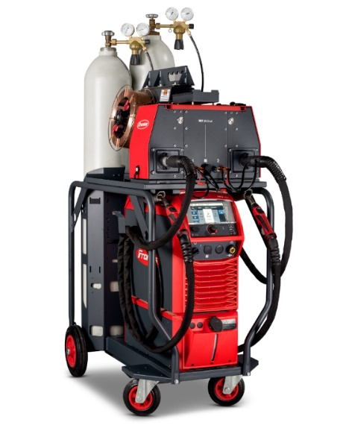
Two-in-one: With the Dual Wire Feeder, the welder can switch between different wire strengths or materials by simply reaching for the second torch. This makes a second welding system superfluous and the work process much more efficient.

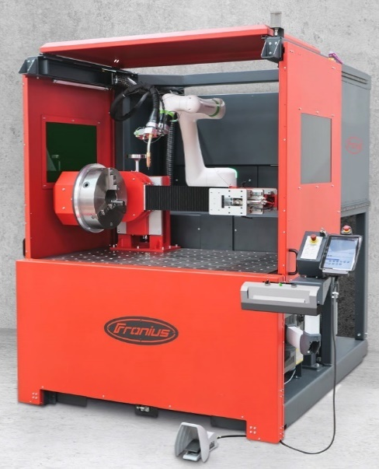

Consistent welding quality from the first to the last piece, with the compact Fronius CWC-S Cobot welding cell, including a rotary unit and optional tailstock. While the Cobot carries out routine welding work, welders can devote their time to more complex tasks.

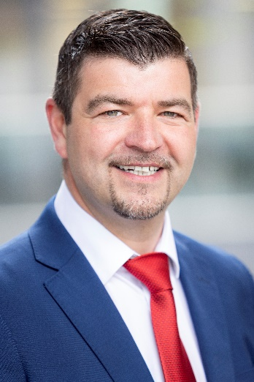
Harald Scherleitner, Global Director of Sales and Marketing, Business Unit Perfect Welding, Fronius International GmbH

“We have big plans for 2023. As always, our customers come first. Therefore, as a reliable joining technology partner, we want to be close to all of our customers worldwide and offer them the best welding solutions. Above all, we are using our expertise to counter the increasing shortage of skilled workers, to use resources and energy efficiently, and to fully exploit the potential offered by digitization and automation.”

Business Unit Perfect Welding
Fronius Perfect Welding is an innovation leader for arc welding and a global market leader for robot-assisted welding. As a systems provider, the Fronius Welding Automation division also implements customized automated complete welding solutions, for the construction of containers or offshore cladding for example. The range is rounded off by power sources for manual applications, welding accessories, and a broad spectrum of services. With more than 1000 sales partners worldwide, Fronius Perfect Welding has great customer proximity.

We are Fronius.
Over 6100 employees worldwide, a current export share of 89 percent, and 1366 active patents: that’s us, that’s Fronius. Founded in 1945 as a regional one-man operation, we are now a global player - a fact that is impressively demonstrated by our 37 international subsidiaries and our network of sales partners in more than 60 countries. And yet, at our core, we are still a family-owned company from Austria, active in photovoltaics, welding, and battery charging technology. We have always developed products and solutions for a future worth living, offering our customers an all-in-one package in the process: from advance planning and consulting to ongoing monitoring and a repair service tailored to their specific needs. We are innovative. We are curious. We are Fronius.

For more information, please contact:
India:
FRONIUS INDIA PVT. LTD; Geeta Kshirsagar
GAT no 312, Nanekarwadi, Chakan, Taluka- Khed District
Pune 410 501
Phone: +91 9607987766
E-Mail: marketing.india@fronius.com

Fronius International:
Frau Heidemarie Haslbauer Tel.: +43 (664) 88293709,
E-Mail: haslbauer.heidemarie@fronius.com

Please send an author's copy to our agent:
a1kommunikation Schweizer GmbH, Frau Kirsten Ludwig,
Oberdorfstraße 31 A, 70794 Filderstadt, Deutschland
tel.: +49 0 711 9454161-20,
e-mail: kirsten.ludwig@a1kommunikation.de

For more exciting updates, visit our blog at blog.perfectwelding.fronius.com and follow us on Facebook (froniuswelding), Twitter (froniusintweld), LinkedIn (perfect-welding), Instagram (froniuswelding) and YouTube (froniuswelding)!

