PRESS RELEASE

Join Fronius UK for an Exclusive High-Performance Welding Event in Milton Keynes
Fronius UK invites welding professionals, enthusiasts, and industry experts to its Technology Centre in Milton Keynes on September 11th for a day dedicated to high-performance welding applications and processes. This exclusive event promises to elevate both your welding knowledge and expectations, showcasing how some of the latest technology can address the unique challenges faced by welders within yellow goods, commercial transportation and general industry.
Sheldon Brear, Segment Manager at Fronius UK, stated, “The great thing about the welding industry is that we never stop learning. There are always new challenges from all segments of our industry, and at Fronius, we are always up for that challenge. As a result, we are continuously developing new processes, collaborating with industry experts, and exploring new innovations. We want to set aside a day to invite everyone from the world of welding to come along and share our journey of discovery.”
Event Highlights
Expert insights and guest speakers
You are guaranteed to gain valuable knowledge from industry-leading experts who will be discussing their own experiences, challenges and solutions in the welding world.
Live product demonstrations and hands-on experience
Witness the capabilities of Fronius' innovative welding systems in action. Discover how the TransSteel Pulse and TPS/i manual systems can enhance your welding processes across all grades of steel and aluminium.
Engage with both robotic and semi-automated welding technologies. Experience the future of welding with demonstrations of the Fronius COBOT and Smart Cell and learn about the benefits of high-performance laser-hybrid welding. Additionally, explore the TWIN wire process, designed to improve production efficiency through high deposition rates and faster welding speeds, and see the versatile AccuPocket system in action, offering cordless welding solutions for on-the-go repairs.
Networking opportunity
This is a great chance to network, providing the opportunity to meet fellow technology enthusiasts and industry professionals to discuss topics such as welding application challenges, research and development, education and recruitment needs.

The event is completely free to attend and a hot lunch and refreshments will be provided throughout the day.
Why Attend?
Whether you want to enhance your existing skills with practical knowledge and the latest insights, discover new technologies and processes that can significantly improve your welding efficiency and quality, or you simply want to learn how to utilise your investments in Fronius technology to their full potential, be sure to secure your spot.
To find out more about the event and to register please visit:
www.fronius.co.uk/pw-hpevent

Fronius UK Ltd
01908 512300
info-uk@fronius.com

2,867 characters including spaces

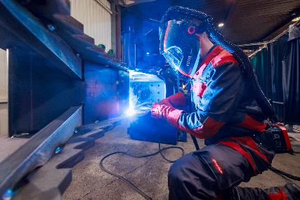 | Discover how the TransSteel Pulse and TPS/i manual systems can enhance your welding processes
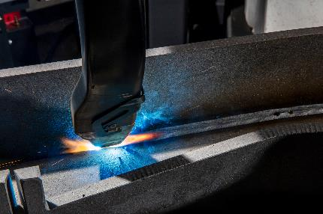 | The TPS/i TWIN Push system enables tandem welding with the very best results: Two TPS/i high performance power sources form the basis for perfectly synchronized arcs that generate a common weld pool – ensuring the process is extremely stable.
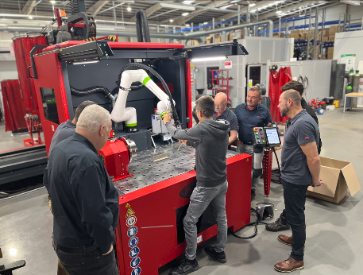 | Experience the future of welding with demonstrations of the Fronius COBOT cell
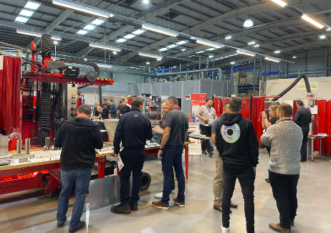 | Fronius UK invites welding professionals, enthusiasts, and industry experts to its Technology Centre in Milton Keynes
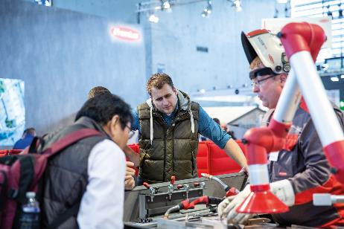 | Witness the capabilities of Fronius' innovative welding systems in action.

Additional information

We are Fronius.
Over 7,000 employees worldwide, a current export share of 89 percent, and 1366 active patents: that’s us, that’s Fronius. Founded in 1945 as a regional one-man operation, we are now a global player - a fact that is impressively demonstrated by our 37 international subsidiaries and our network of sales partners in more than 60 countries. And yet, at our core, we are still a family-owned company from Austria, active in photovoltaics, welding, and battery charging technology. We have always developed products and solutions for a future worth living, offering our customers an all-in-one package in the process: from advance planning and consulting to ongoing monitoring and a repair service tailored to their specific needs. We are innovative. We are curious. We are Fronius.

We are Perfect Welding.
Maximum arc quality, a deep understanding of our customers, a thirst for technical progress: this is what drives us at Fronius Perfect Welding. We are the innovation leader for arc welding and the global market leader for robot-assisted welding. Our customised, automated complete systems and digital welding solutions for Industry 5.0 are the product of our expertise. Intuitive welding systems for manual welding applications, high-quality welding accessories, and effective protective products to keep users safe round off our portfolio. As a global company, we offer regional service through local teams who are on hand for our customers around the world. Our technologies break new ground and form connections – between metals, industries, and people.

