PRESS RELEASE

Sustainable heating with biomass

Innovation champion Guntamatic manufactures boilers using premium welding technology from Fronius
Guntamatic GmbH operates internationally, producing high-tech biomass heating systems. From fully automatic log wood heating systems to pellet heating, Guntamatic continually demonstrates itself to be the innovation leader in its industry. The company has always used Fronius welding technology to ensure the high-quality production of its products. Since the product's release in 2020, the Austrian family-run company has put its trust in the Fronius TransSteel 4000 Pulse to improve overall manual welding efficiency.

A true Austrian success story, the small family-run company Guntamatic from rural Peuerbach started trading in 1963 with the production of log wood boilers and has since become the international industry pioneer in biomass heating. Biomass technology started to boom in the 1980s and Guntamatic began to expand and see its first competitors. In the 1990s, it was becoming clear that biomass heating systems could be operated as a fully-fledged alternative to oil and gas heating systems since they were CO₂-neutral.
Guntamatic’s hybrid heating systems are the perfect combination of electric heat and biomass combustion. Based on user preferences, when the demand for heat rises due to cold weather, the unit will automatically switch to either the most cost-effective or the most efficient heating method.
However, Guntamatic systems do not just set new standards in heating, but also in overall comfort. Heat generation is no longer the only way that Guntamatic succeeds in increasing comfort at home, atmospheric and elegantly-designed heating elements in the fireplace bring the combustion process, and the resulting cosy radiant heat, into the living room.

Sustainability, cost-effectiveness and efficiency
“With the rise of pellet heating systems, the industry has continued to develop strongly since the beginning of the 2000s,” explains Günther Huemer, Managing Director of Guntamatic GmbH. In the meantime, the medium-sized company, which now employs around 250 people, has continued to grow in line with industry trends. This has affected production. “We have to retain our cost-effectiveness in all areas, while continuing to deliver the highest levels of quality. A high degree of automation, particularly in sheet metal forming, is required to remain competitive against companies in low-wage countries.”
However, Guntamatic does not pursue cost-effectiveness at the expense of sustainability. “The production of our heating systems focuses on durability,” states Huemer. “We try to produce sustainable, clean and reliable products. Our ecological footprint is extremely important to us, and this sustainability, as well as quality, is something we also demand from our business partners. The long service life and quality of purchased products and raw goods is thus of utmost importance to us.”
In this respect, the company also relies on close and trusting relationships with its suppliers. “We almost never switch our business partners,” explains Huemer. “We place great importance on good, fast and reliable support. As such, one of our partners is Fronius, which has guided us from the very beginning in the field of manual welding.”

Production and joining technology
“Almost all Guntamatic products are made in Peuerbach,” explains master metalworker Roland Fellinger, who coordinates the welding operations at Guntamatic. “The only things supplied to us are the metal sheets and raw materials. Processing, parts production, and assembly are almost entirely completed in-house. We try to avoid purchasing parts.” All components are manufactured using CNC punching machines and other high-tech, automated machines before being handed over for joining. The welding of the boilers and their long seams is mostly automated.
However, when it comes to tacking the boiler joints and welding the inner workings, robotic welding is no longer the most efficient option. Due to the restricted component accessibility, manual welding is the method of choice, “Here, we primarily add black and white connections, i.e. steel with stainless steel,” adds master metalworker Fellinger. “The box-shaped boilers have difficult corner joints that have to be constantly refinished by the manual welders.”
“In addition, we are working with the complete range of sheet thicknesses. We predominantly switch between intermediate and spray arc, so the choice of materials make the conditions really difficult.” In the past, this meant high levels of refinishing were required.

Guntamatic modernises the manual welding sector
“Our main goal was to reduce the refinishing costs,” confirms Fellinger. Indeed, from the very beginning, Guntamatic has been working exclusively with Fronius welding systems for manual welding, including the VarioSynergic (3500/4000), the TransPocket, and the MagicWave for TIG welding. In order to meet the demands for making work easier and reducing costs, MIG/MAG pulse welding seemed the most up-to-date and effective solution.
“After Fronius launched the TransSteel Pulse series in 2020, we decided it was time to modernise,” explains Fellinger. “The pulse welding function enables us to work with significantly greater process stability, while at the same time substantially reducing welding spatter. Since then, we have integrated numerous TransSteel 4000 Pulse welding systems into our production. As a result, manual welding has become much cleaner, and we have been able to reduce the amount of reworking required.
Furthermore, ease of use is something that is really important to us, and that’s something Fronius was able to deliver with the TransSteel 4000 Pulse. As a result, the welding system could be integrated and ready for use in just a few steps.”

Professional support in sales and servicing
However, if welders still have questions about handling, system care and maintenance, Fellinger is clear, “Fronius is a top company and delivers top quality. That means that good sales and servicing are always available to us, something that is particularly important to us with regards to our productivity, because this cooperation ensures quick decisions and short turnarounds.”
“We almost never switch business partners if we are happy with the partnership,” expands Managing Director Huemer. “And Fronius has been one of our suppliers from the very beginning. The Fronius brand stands for a level of quality that we need in the field of welding, because, when it comes to quality assurance, our main focus is on the welding technology, because this has a significant effect on the life cycle of our products.”

Fronius also stands for sustainability at Guntamatic
Moving beyond welding technology, Fronius also supports Guntamatic in the area of sustainability. “In light of our corporate philosophy, we place great importance on improving sustainability in the use of energy at our production site. It’s about carbon-neutral production, and, in this context, our attention was naturally drawn back to Fronius.”
“The question was who belonged to the leading suppliers in the area of solar energy, and we are delighted that we are now able to operate our 20,000-m² photovoltaic system with Fronius inverters.”

7,279 characters incl. spaces

Image captions:

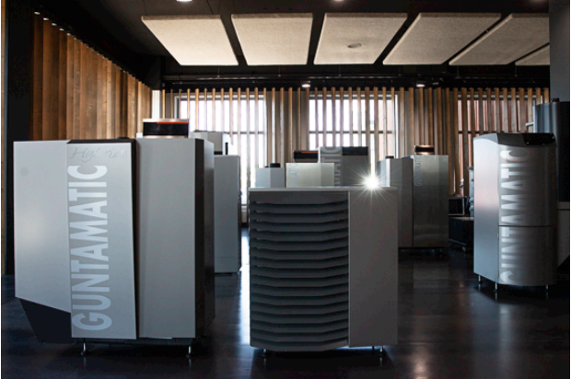

Image 1: Guntamatic builds biomass heating systems in the high-tech segment.

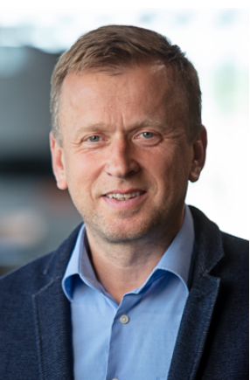

Image 2: Günther Huemer, Director of Guntamatic GmbH.
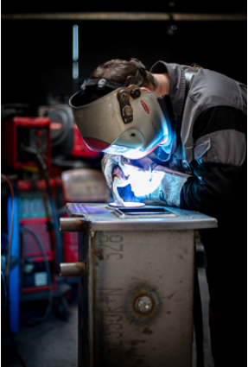

Image 3: TransSteel Pulse being used at Guntamatic. The interior of the boilers is welded exclusively by hand.

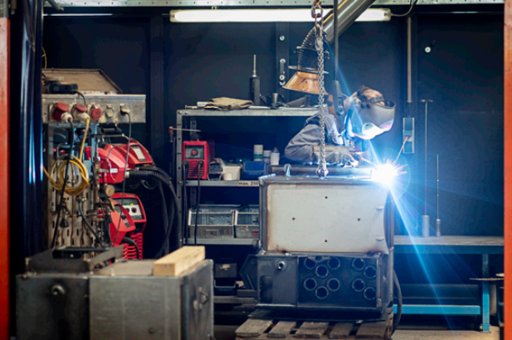

Image 4: After robotic welding, difficult corner joints are reworked by hand using the TransSteel Pulse.

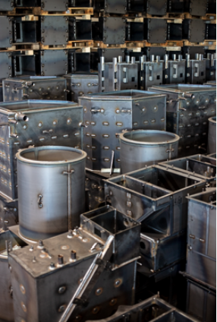

Image 5: Huge boilers manufactured using steel and stainless joints..

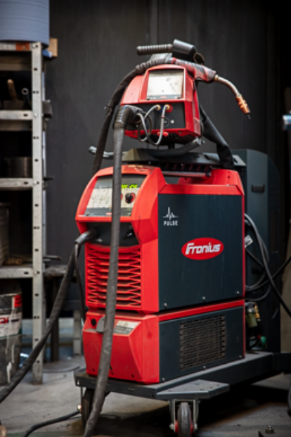

Image 6: The Fronius TransSteel 4000 Pulse: the welding system Guntamatic chose to modernise their manual welding operations.

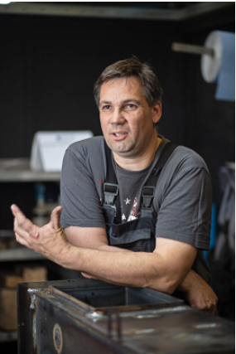

Image 7: Roland Fellinger, master metalworker and welding supervisor at Guntamatic.

Copyright to photos: Fronius International GmbH, reproduction free of charge

High-resolution images are available to download at the following link:
www.fronius.com/en/welding-technology/infocentre/press

Business Unit Perfect Welding
Fronius Perfect Welding is the innovation leader for arc welding and is the global market leader for robot assisted welding. As system providers, Fronius Welding Automation also turns customer-specific automated complete welding solutions into reality in a number of areas, from container construction right up to cladding for the offshore sector. Power sources for manual applications, welding accessories and a wide range of services add to our portfolio. With more than 1,000 sales partners worldwide, Fronius Perfect Welding is never far away from our customers.

Fronius International GmbH
Fronius International GmbH is an Austrian company with headquarters in Pettenbach and other sites in Wels, Thalheim, Steinhaus and Sattledt. With 5,660 employees worldwide, the company is active in the fields of welding technology, photovoltaics and battery charging technology. 92% of its products are exported through 36 international Fronius subsidiaries and sales partners/representatives in over 60 countries. With its innovative products and services and 1,321 granted patents, Fronius is the global innovation leader.

Contact details for publishing:
Fronius UK Ltd
+44 1908 512300
info-uk@fronius.com
www.fronius.co.uk

For more information, please contact:
Fronius UK Ltd; Miss Kim Lee;
Maidstone Road, Kingston, Milton Keynes, MK10 0BD
Phone: +44 1908 512340
E-Mail: lee.kim@fronius.com

Please send a specimen copy to our agency:
a1kommunikation Schweizer GmbH, Kirsten Ludwig,
Oberdorfstraße 31 A, 70794 Filderstadt, Germany
Phone: +49 0 711 9454161-20
E-Mail: kirsten.ludwig@a1kommunikation.de

For more exciting updates, visit our blog at blog.perfectwelding.fronius.com and follow us on Facebook (froniuswelding), Twitter (froniusintweld), LinkedIn (perfect-welding), Instagram (froniuswelding) and YouTube (froniuswelding)!

