News release
Perfect Welding

FERRUM.AT

Efficient welding with the iWave
Big success stories often begin in small garages. This is also the case with Ferrum.at. In 2009, Hannes Holl founded a small metalworking company in Schwertberg, Upper Austria, which evolved into a renowned contract manufacturer for industry and commerce within just a few years. Today, the company, which holds multiple certificates, manufactures a variety of metal components for well-known national and international clients. In search of intelligent, multifunctional welding systems for MIG/MAG applications, FERRUM.AT Metallverarbeitung GmbH found the right partner in Fronius, not only to improve welding quality and efficiency, but also their own competitiveness.

Combined design and welding competence
The medium-sized company is not only known for its immense flexibility in high-quality contract manufacturing work, but also supports the development of new products and prototypes that are ready for series production. Aluminum, steel, stainless steel, brass, and copper are welded in different sheet thicknesses. Dedicated professionals, Solid Works 3D software, and high-quality machinery including laser, rolling, and bending systems, as well as digital high-tech welding systems are all available for this purpose. Many of the often challenging tasks begin with extensive feasibility checks, during which the experienced FERRUM.AT experts evaluate the weldability of components in terms of design, material, and dimension, the suitability of welding processes, or the effect of welding sequences on component distortion. Even complex clamping devices are designed.
The cross-industry service and product portfolio is extremely broad and ranges from outdoor facilities to roof components, facade and steel construction elements, pressure vessels, machine and wagon components, and designs for bridge construction. The company welds for customers from Germany to Greece.

MIG/MAG & TIG—two welding systems were one too many
Time and again component accessibility, material, and design require that individual components be welded using both the MIG/MAG and TIG processes at FERRUM.AT. Before the newly acquired multifunctional welding systems from Fronius were used, two different device types were required: one MIG/MAG and one TIG. The space needed was enormous, and the constant switching between the two welding systems was inefficient. Therefore, they had been looking for efficient and reliable multifunctional welding systems for quite some time. These systems should provide significant time savings and therefore increase efficiency, without compromising on welding quality and causing downtimes.
As a long-standing Fronius customer, the Ennsdorf-based metalworking company was one of the first to test the new iWave AC/DC 400i digital multiprocess device for a month, and the result was impressive. The metalworking company did not have to lower any of their expectations—neither in terms of operation nor the welding results, quite the opposite:
“We now have two unrivalled machines that allow us to rapidly switch between the two welding processes of MIG/MAG and TIG,” says managing director Hannes Holl enthusiastically. “At the same time, we benefit from a considerable time saving, paired with a huge increase in convenience and weld quality. This represents our next step forward as a company. Stagnation is not an option to remain competitive.”

FERRUM.AT increases productivity
The ultra-fast SpeedNet communication between the system components in combination with the high computing power of the iWave enables the use of new advanced welding processes that lead to excellent weld results. Innovative functions such as CycleTIG (for TIG) or PMC (Pulse Multi Control for MIG/MAG) stabilize the arc, optimize the droplet detachment, and reduce the heat input, while at the same time ensuring high deposition rates and constant penetration.
The gap-bridging ability is exemplary, with gap tolerances being automatically compensated for. Even for out-of-position welding, such as in the case of vertical-up seams, 100% control of the weld pool is assured. Higher welding speeds shorten cycle times and significantly increase the already high productivity of these metalworking professionals—all in the interest of FERRUM.AT customers, who benefit from faster lead times.
The visually perfect welds also help to shorten the manufacturing time by preventing time-intensive rework such as removing spatter or grinding off weld reinforcements and, in turn, promoting resource-conserving work.

Time savings of up to 50% when tacking
With the help of the tacking function, the weld pool briefly oscillates at the beginning of the welding process. As a result, tacking takes place in a single step because both component edges merge beautifully—without burning the edges. Very little to no temper coloration occurs at the tacking points. In addition, the filler metal is not required for air gaps up to 1.5 mm. Particularly for chrome-nickel and steel applications, the tacking function leads to a significant increase in efficiency.

When a welding system thinks for itself
Top-quality manual welding requires years of experience and dexterity. This is especially true for TIG welding. The more intuitive and convenient a welding system is to operate and the more it supports welders with their welding work through intelligent functions, the better they can focus on the actual task: the perfect weld result. The iWave makes things much easier for the professionals at FERRUM.AT. The menu navigation is self-explanatory and available in more than 30 languages. Operating the touch display and adjustment wheel even while wearing gloves is easily possible.
“RPI auto” takes TIG welding ignition behavior to a whole new level. Adapted to the different electrode diameters, this function enables fast and reproducible ignition without any manual adjustment of the ignition parameters, regardless of the material characteristics.
If the professionals at FERRUM.AT want to repeat certain welding parameters, they can create “Jobs” in the iWave and subsequently call up to 1,000 of them on the JobMaster welding torch. This eliminates the need to move back and forth between the component and the welding system as soon as new welding parameters are needed. Recurring jobs can be saved in iWave as favorites, five of which can be set as so-called “Easy Jobs” on the welding torch. This is an enormous gain in convenience for welding tasks that have to be performed over and over again.
Depending on the job, the iWave itself recognizes when it has to change from MIG to TIG for certain applications and vice versa. It automatically changes the necessary parameter settings and lowers the main current slowly and in a controlled manner for a clean weld toe. All these functions support the welding professionals in achieving the desired weld seam quality.
Above all, welding engineer Stefan Aumayr would not want to be without the handy WeldConnect app: “As soon as I enter the base material, filler metal, shielding gas, weld seam profile, and the desired speed into the app, I receive sensible welding parameters for the next welding task in a split second. I then transfer these from my cellphone to the iWave via Bluetooth in no time. If I’m still not satisfied with the weld result, I only need to do some finetuning. My many years of experience help me with this. I save the welding parameters found this way in the iWave and can access them at any time. I simply make the selection on the JobMaster welding torch when I need it.”

Ready for large tasks at any time
At FERRUM.AT, the focus was on development from the start. Within twelve years, the company evolved from a small contract manufacturer to a renowned, nationally known, and sought-after partner for high-quality welded constructions. There are hardly any limits in terms of components and industries. The company is certified according to EN 1090-1EXC3, ISO 3834-3, and EN 15085-2.
“We rise to just about any challenge. This is also in the interests of my employees, of whom I am particularly proud and on whom I can rely one hundred percent. They are with me through thick and thin. They also don’t shy away from any task, no matter how difficult it may be, quite the opposite: they seek it out,” explains Holl.
Welding is carried out in accordance with a WPS (welding procedure specification), which is usually prepared by in-house experts or by the company’s own welding coordination personnel for the individual tasks. And when it comes to expanding skills and the range of services offered, they do not shy away from either welding or process tests, true to the motto “Stagnation is not a recipe for success!”
Holl concludes: “In addition to professional qualifications, the health of my staff is of great importance to me. That’s why we provide the best personal protective equipment possible, such as respiratory protection systems with a fan filter unit, and I meticulously make sure that it is actually being used.”

7,644 characters excluding spaces
This news release and the images can be downloaded from: https://www.fronius.com/en/welding-technology/info-centre/press
Photos: Fronius International GmbH; reprints free of charge

Images

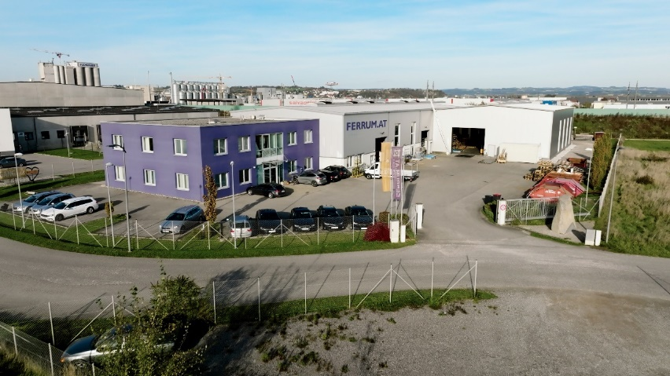
Image 1: FERRUM.AT Metallverarbeitung GmbH plant in Ennsdorf, Austria

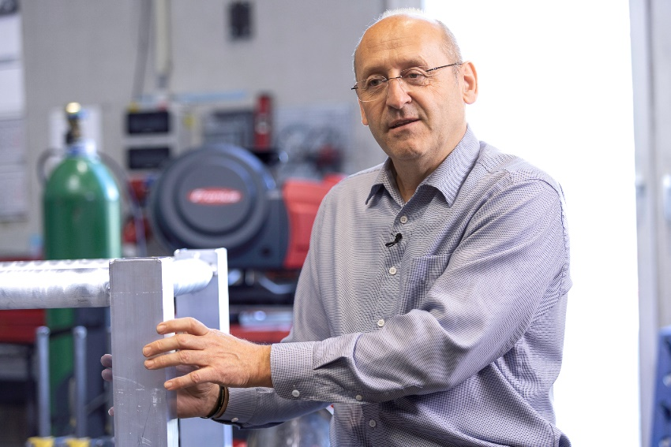
Image 2: Hannes Holl, Managing Director

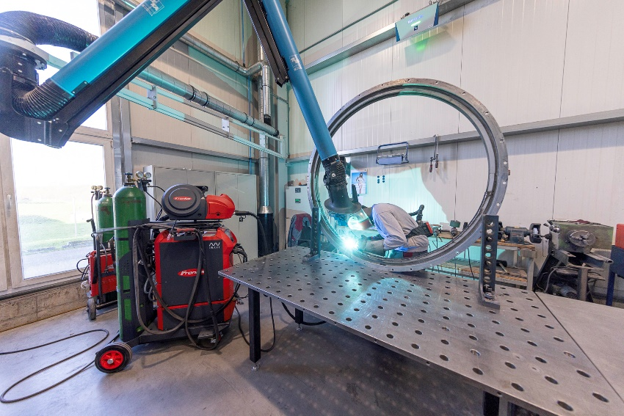
Image 3: MIG repair welding with the iWave
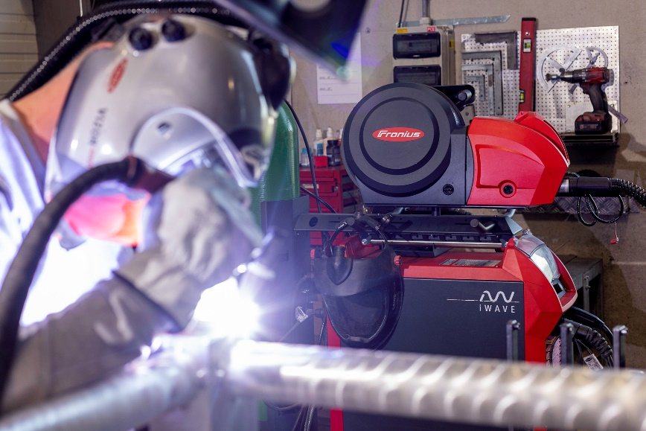
Image 4: TIG welding with the iWave

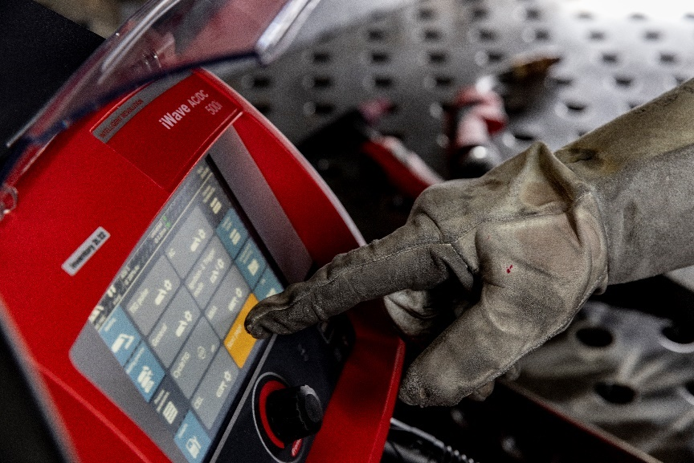
Image 5: Intuitive touch display—even while wearing gloves

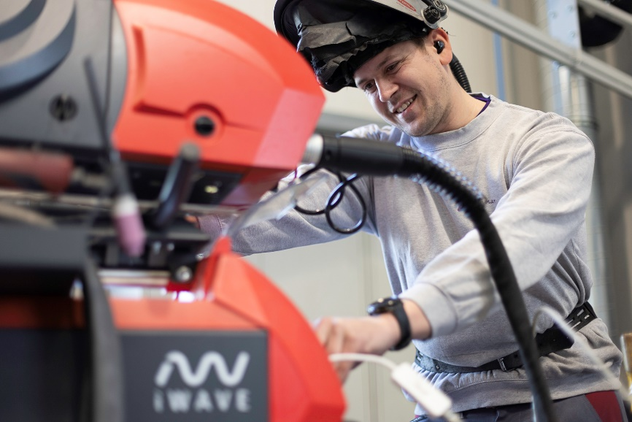
Image 6: Stefan Aumayr, Metal and Sheet Metal Engineer
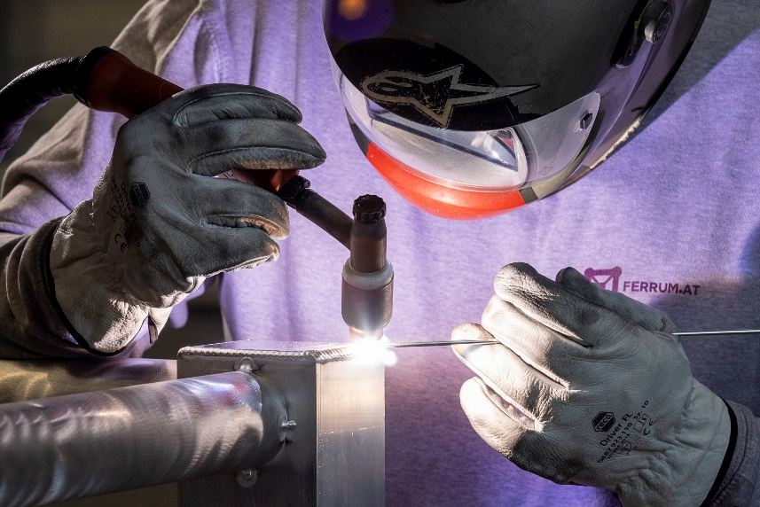
Image 7: TIG application

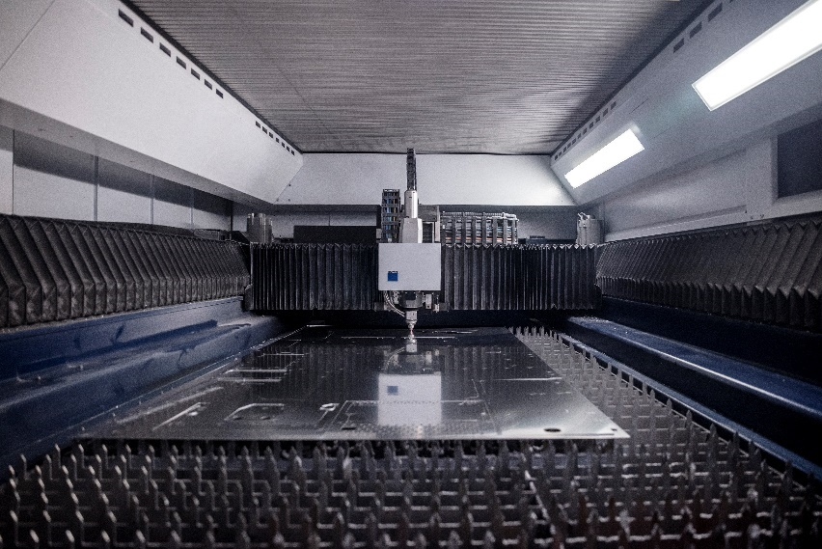
Image 8: Laser system

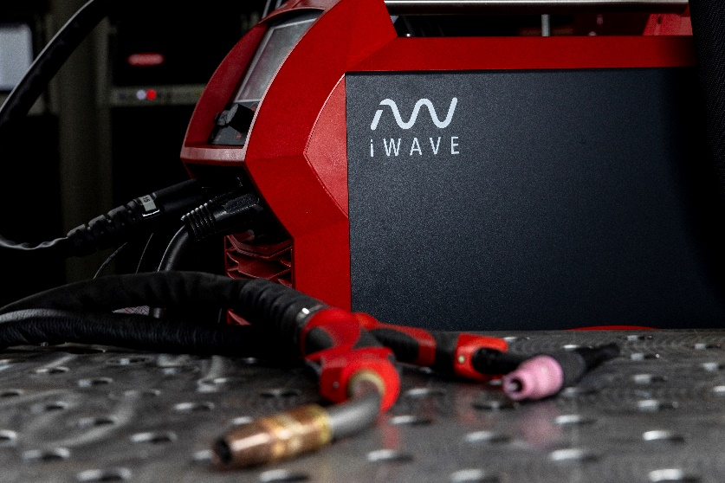
Image 9: iWave multiprocess welding system

We are Fronius
Over 7,000 employees worldwide, a current export share of 87 percent, and 1446 active patents: that’s us, that’s Fronius. Founded in 1945 as a regional one-man operation, we are now a global player - a fact that is impressively demonstrated by our 37 international subsidiaries and our network of sales partners in more than 60 countries. And yet, at our core, we are still a family-owned company from Austria, active in photovoltaics, welding, and battery charging technology. We have always developed products and solutions for a future worth living, offering our customers an all-in-one package in the process: from advance planning and consulting to ongoing monitoring and a repair service tailored to their specific needs. We are innovative. We are curious. We are Fronius.

We are Perfect Welding
Maximum arc quality, a deep understanding of our customers, a thirst for technical progress: this is what drives us at Fronius Perfect Welding. We are the innovation leader for arc welding and the global market leader for robot-assisted welding. Our customized, automated complete systems and digital welding solutions for Industry 5.0 are the product of our expertise. Intuitive welding systems for manual welding applications, high-quality welding accessories, and effective protective products to keep users safe round off our portfolio. As a global company, we offer regional service through local teams who are on hand for our customers around the world. Our technologies break new ground and form connections – between metals, industries, and people.

For more information, please contact:
United States:
Fronius USA LLC, Ms. Rhonda Zatezalo
6797 Fronius Drive, 46368 Portage, IN
Tel: +1 219 734 5701,
E-Mail: zatezalo.rhonda@fronius.com

Canada:
Fronius Canada Ltd., Mr. Ted Clifford
2875 Argentia Road, Units 3 – 6 Mississauga, ON L5N 8G6
Tel.: +1 905 288 2128,
E-Mail: clifford.ted@fronius.com

South Africa:
Fronius South Africa Pty Ltd; Edric Van der Walt
Dytchley Road, Barbeque Dawns, 1685 Midrand, South Africa
Phone: +27 65 686 8286
E-Mail: VanderWalt.Edric@fronius.com

India:
FRONIUS INDIA PVT. LTD; Pranjali Ghanekar
Plot no. BG 71/2/B, Pimpri Industrial Area, MIDC Bhosari,
Pune – 411026, Maharashtra, India
Phone: +91 73910 87915
E-Mail: marketing.india@fronius.com

Fronius International:
Frau Heidemarie Haslbauer Tel.: +43 (664) 88293709,
E-Mail: haslbauer.heidemarie@fronius.com

Please send an author's copy to our agent:
a1kommunikation Schweizer GmbH, Frau Kirsten Ludwig,
Oberdorfstraße 31 A, 70794 Filderstadt, Deutschland
tel.: +49 0 711 9454161-20,
e-mail: kirsten.ludwig@a1kommunikation.de

For more exciting updates, visit our blog at blog.perfectwelding.fronius.com and follow us on Facebook (froniuswelding), LinkedIn (perfect-welding), Instagram (froniuswelding) and YouTube (froniuswelding)!

