News release
Perfect Welding

Effective welding fume extraction

Fronius presents two new, powerful extraction systems and an ergonomic fume extraction torch

The greatest possible protection from welding fume is more than just compliance with standards. Going beyond the standards shows companies take responsibility for their welding specialists, and everyone working in their immediate vicinity. To assist, Fronius is launching the user-friendly Exento extraction welding torch and two mobile, high-performance Exento extraction systems as effective protection against welding fumes.
These new extraction solutions are a perfectly coordinated duo, consisting of the ergonomically designed Exento fume extraction torch and the compact, mobile high-vacuum extraction system Exento HighVac. This combination is particularly effective for MIG/MAG welding, removing welding fume as soon as it is created. Thanks to the high-quality filter, the Exento HighVac mobile extraction system eliminates more than 99.9 percent of the captured welding fume particles.
The Exento LowVac is a low-vacuum extraction system suitable for all welding processes, such as MIG/MAG, TIG, and MMA, with an impressive flow-optimized extraction hood design. As a result, significantly less extraction arm tracking is required than with conventional systems.
The new fume extraction torch – powerful, manageable, and individual
With the newly designed and EN ISO 21904-1-compliant Exento fume extraction torch, welding fume is captured with pinpoint accuracy, before it can spread. In the design phase, our development team paid particular attention to optimal ergonomic design and easy operation. For example, the desired extraction level can be controlled directly on the handle with a bypass valve. Rubber inserts ensure a non-slip grip, and the included LED lighting proves useful when welding in dark areas, and for quality control. With three different choices of user interface, from a torch trigger on the top to an up/down rocker and the JobMaster, there is a torch type for every welder. The torch also offers significantly more freedom of movement while welding through the use of the ball joint that attaches it to the 1.3 meter long, leather-protected hose.
Exento HighVac - mobile and compact extraction
In combination with the fume extraction torch, the new Exento high-vacuum extraction system demonstrates its power where continuous performance is required to remove fumes and dust. With a footprint of just 60 x 60 centimeters, and an operating radius of 360 degrees, it is a flexible powerhouse that can be used wherever it is needed. The integrated side-channel compressor allows an extraction capacity of up to 170 m³ per hour, and the vertically mounted filter cartridge ensures particularly effective cleaning. To ensure maximum ease of use, we included features such as the single button operation and the stepless pre-selection for power levels. Program selection is possible in next to no time, even while wearing gloves.
The new Exento fume extraction torch and the Exento HighVac extraction system are a perfect match and achieve excellent results. Nevertheless, the high-vacuum extraction system can be combined with other fume extraction torches.
Exento LowVac – versatility in action
Whether MIG/MAG, TIG, or MMA welding: this compact, mobile, low vacuum extraction system is suitable for all common welding processes. Exento LowVac is the right choice for wherever fume extraction torches cannot be used. Its highlight is the 360-degree rotatable extraction hood with throttle valve with optional LED lighting. Equally remarkable is the large, standard 25 m² filter area of the disposable filter, which can be upgraded to 42 m² if required. The robust and stable design makes the Exento LowVac the perfect companion when frequent workplace changes are needed. Thanks to the high capacity and the long service life of the filter, the system is also extremely cost effective.
Fronius rounds out its extensive range of health and safety protection products with the new, innovative Exento products. You can find more details here!
The Fronius team is also looking forward to demonstrating the Exento extraction systems and numerous other Fronius innovations for you this September at FABTECH in Chicago, Booth B27027 or at the SCHWEISSEN & SCHNEIDEN trade show in Essen, Germany, Hall 3, Stand 3B55.

3,707 characters (including spaces)

This news release and the images can be downloaded from: https://www.fronius.com/en/welding-technology/info-centre/press

Photo credits: Fronius International GmbH; reprints free of charge

Images

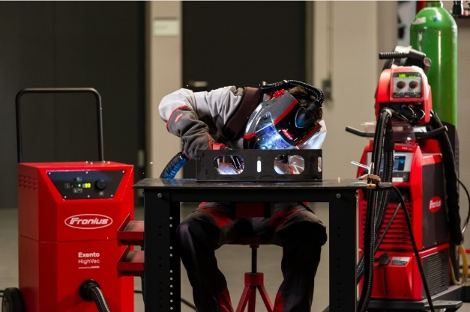
Welding fumes may cause permanent, serious health damage. Powerful extraction systems, such as the Fronius Exento HighVac, protect not only the welding specialists, but also those around them.

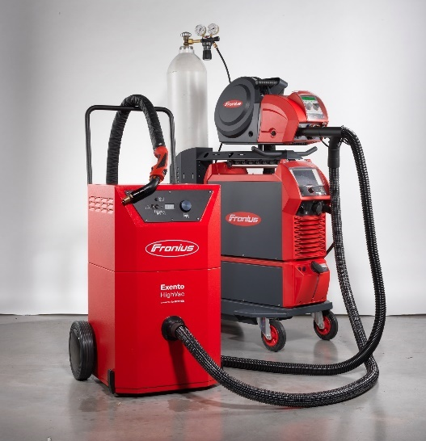
A perfectly coordinated duo from a single source: Exento HighVac high-vacuum extraction system and the ergonomic Exento fume extraction torch.

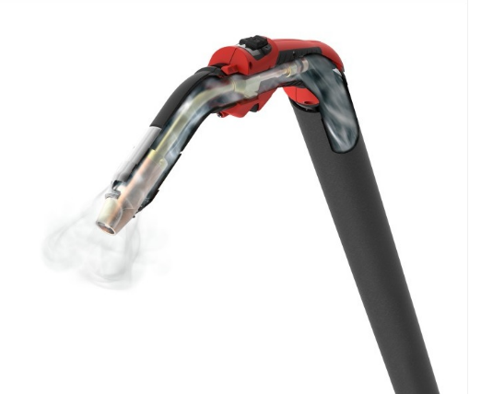
The ergonomic Exento fume extraction torch sits comfortably in your hand and, thanks to the bypass valve, the extraction power level can be controlled on the handle. Depending on requirements, the torch is available as JobMaster, up/down rocker switch, and top torch trigger user interfaces.

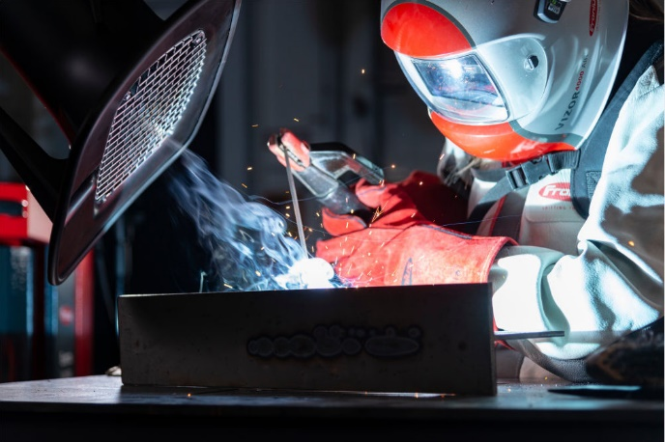
The powerful Exento LowVac extraction system with flexible extraction arm is characterized by its large-area coverage.

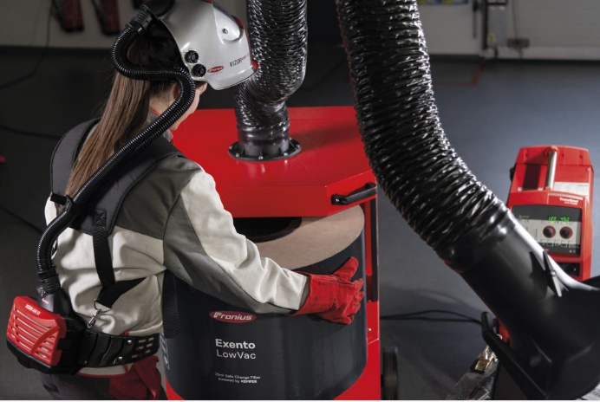
The filter of the Exento LowVac has a particularly high capacity, and offers increased safety for welding personnel through contamination-free replacement.

We are Fronius
Over 7,000 employees worldwide, a current export share of 87 percent, and 1446 active patents: that’s us, that’s Fronius. Founded in 1945 as a regional one-man operation, we are now a global player - a fact that is impressively demonstrated by our 37 international subsidiaries and our network of sales partners in more than 60 countries. And yet, at our core, we are still a family-owned company from Austria, active in photovoltaics, welding, and battery charging technology. We have always developed products and solutions for a future worth living, offering our customers an all-in-one package in the process: from advance planning and consulting to ongoing monitoring and a repair service tailored to their specific needs. We are innovative. We are curious. We are Fronius.

We are Perfect Welding
Maximum arc quality, a deep understanding of our customers, a thirst for technical progress: this is what drives us at Fronius Perfect Welding. We are the innovation leader for arc welding and the global market leader for robot-assisted welding. Our customized, automated complete systems and digital welding solutions for Industry 5.0 are the product of our expertise. Intuitive welding systems for manual welding applications, high-quality welding accessories, and effective protective products to keep users safe round off our portfolio. As a global company, we offer regional service through local teams who are on hand for our customers around the world. Our technologies break new ground and form connections – between metals, industries, and people.

For more information, please contact:
United States:
Fronius USA LLC, Ms. Rhonda Zatezalo
6797 Fronius Drive, 46368 Portage, IN
Tel: +1 219 734 5701,
E-Mail: zatezalo.rhonda@fronius.com

Canada:
Fronius Canada Ltd., Mr. Ted Clifford
2875 Argentia Road, Units 3 – 6 Mississauga, ON L5N 8G6
Tel.: +1 905 288 2128,
E-Mail: clifford.ted@fronius.com

Fronius International:
Frau Heidemarie Haslbauer
Tel.: +43 (664) 88293709,
E-Mail: haslbauer.heidemarie@fronius.com

Please send an author's copy to our agent:

a1kommunikation Schweizer GmbH, Frau Kirsten Ludwig,
Oberdorfstraße 31 A, 70794 Filderstadt, Deutschland
Tel.: +49 0 711 9454161-20,
E-Mail: kirsten.ludwig@a1kommunikation.de

For more exciting updates, visit our blog at blog.perfectwelding.fronius.com and follow us on Facebook (froniuswelding), LinkedIn (perfect-welding), Instagram (froniuswelding) and YouTube (froniuswelding)!

