News release
Perfect Welding

Fronius UK to host Cobot Open Day in March
Find out how you can elevate your production processes with a Fronius Cobot Welding Cell.
Join Fronius UK on Wednesday March 26th, for an engaging Cobot Open Day in Milton Keynes, where you can explore the incredible capabilities of the CWC-S and Mobile Cobot Welding Systems. These advanced collaborative robots are transforming the manufacturing landscape by offering unmatched precision, efficiency, and safety in welding processes. Suitable for both intricate, small components and larger fabrications, Fronius Cobot Welding Cells provide a versatile solution for a wide range of welding requirements.
The event will highlight how Fronius Cobot Welding Cells can significantly enhance production processes. One of the key advantages of these systems is their user-friendly interface, which allows operators of varying skill levels to use them effectively. The drag-and-drop programming feature eliminates the need for extensive training or programming skills, enabling quick and seamless integration into existing production lines. This accessibility ensures consistently high-quality welds, with precise torch movements backed by intelligent technology.
Attendees will have the opportunity to witness the unique features of the CWC-mobile model, which combines a compact design with exceptional mobility. This model is ideal for welding applications that require flexibility in location. Additionally, the CWC-S system is designed for small to mid-sized production runs, integrating state-of-the-art robotics with Fronius' well-established welding expertise. The Cobot Welding Cells are paired with Fronius intelligent TPS/i technology which offers a range of high-tech welding packages.
Incorporating cobots into welding operations offers numerous benefits beyond just precision and efficiency. Cobots are designed to work alongside human operators, enhancing workplace safety by reducing the risk of injuries often associated with traditional welding methods. Their collaborative nature ensures that they can take on repetitive tasks, allowing skilled welders to focus on more complex and creative aspects of their work. This division of labour not only improves the overall productivity of a team but also maximises the use of human expertise and creativity. Furthermore, cobots help to maintain consistent weld quality, which is crucial in industries requiring high precision and adherence to stringent standards. By minimising human error and fatigue, they ensure that the final products consistently meet high-quality benchmarks.
Even with the highest skilled welding professionals it would be challenging to produce welds with a consistent level of quality and repeatability around the clock. Cobots, on the other hand, master this task with ease, and guarantee 100% reproducible, identical welds. Equipped with modern welding machines from Fronius, such as the TPS 400i CMT or the Multiprocess version iWave 400i AC/DC CMT, a wide range of metals can be welded, including steel, stainless steel, aluminium, copper, and titanium. Innovative Welding Packages, such as Low Spatter Control (LSC), Pulse Multi Control (PMC), or the world-famous Cold Metal Transfer (CMT) can also be used.
The welding cells are also fitted with CE-compliant safety devices including fume extraction which guarantee a safe working environment.
The Open Day is not just about demonstrations; it is an invitation to experience firsthand how these innovative cobot welding cells can streamline operations and boost production capabilities. The event also includes a hot lunch and refreshments, offering a relaxed environment for networking with industry experts and peers.
In addition to showcasing the cobot welding cells, the event will feature demonstrations of the FlexTrack 45 Pro a rail-guided welding carriage for mechanised welding as well as the iWave DynamicWire, which introduces exciting possibilities for automated welding applications. These presentations further underscore Fronius' commitment to advancing welding technology and supporting modern manufacturing needs.
Don't miss this opportunity to improve your production process and discover how Fronius Cobot Welding Cells can transform your operations. Reserve your spot today and join industry professionals in exploring the future of welding automation.

Register for the event here: https://froniuscobot.eventbrite.co.uk

4,293 characters (inc spaces), 616 words
Photos: Fronius International GmbH; reprints free of charge
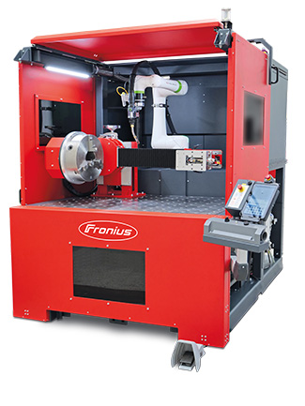
Photo material:

Low investment costs and highly profitable even with small batch sizes.
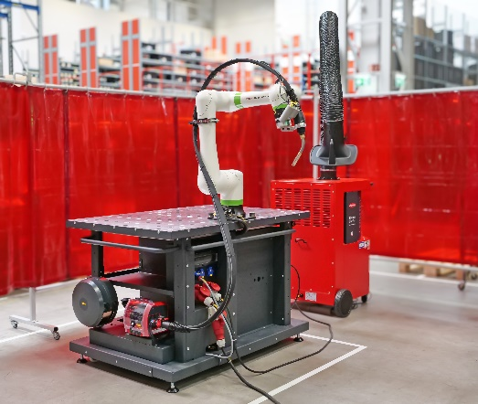

Fronius Mobile Cobot Welding system

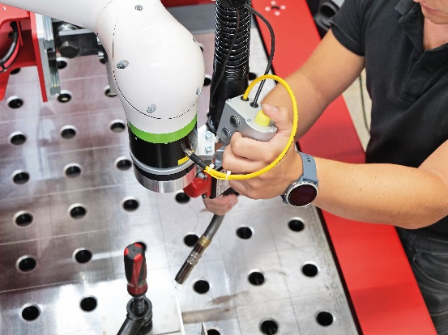

Simple welding path programming with direct torch guidance.
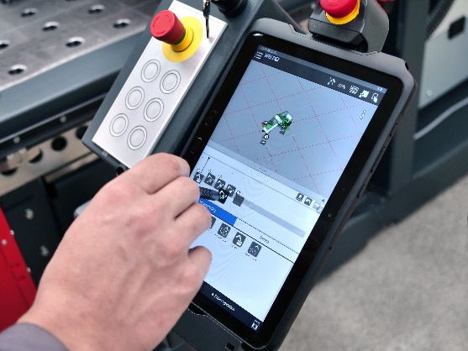

Programme creation via drag and drop

We are Fronius.
Over 7,000 employees worldwide, a current export share of 85 percent, and 1604 active patents: that’s us, that’s Fronius. Founded in 1945 as a regional one-man operation, we are now a global player - a fact that is impressively demonstrated by our 38 international subsidiaries and our network of sales partners in more than 60 countries. And yet, at our core, we are still a family-owned company from Austria, active in photovoltaics, welding, and battery charging technology. We have always developed products and solutions for a future worth living, offering our customers an all-in-one package in the process: from advance planning and consulting to ongoing monitoring and a repair service tailored to their specific needs. We are innovative. We are curious. We are Fronius.

We are Perfect Welding.
Maximum arc quality, a deep understanding of our customers, a thirst for technical progress: this is what drives us at Fronius Perfect Welding. We are the innovation leader for arc welding and the global market leader for robot-assisted welding. Our customised, automated complete systems and digital welding solutions for Industry 5.0 are the product of our expertise. Intuitive welding systems for manual welding applications, high-quality welding accessories, and effective protective products to keep users safe round off our portfolio. As a global company, we offer regional service through local teams who are on hand for our customers around the world. Our technologies break new ground and form connections – between metals, industries, and people.

For more information, please contact:
Fronius UK Ltd; Mrs Kim Lee;
Maidstone Road, Kingston, Milton Keynes, MK10 0BD
Phone: +44 1908 512340
E-Mail: lee.kim@fronius.com

