application story

A 65 Percent Increase in Productivity

Painco relies on high performance welding using the TPS 600i

Brazilian company Painco uses automated welding cells to produce welded components and assemblies from sheet metal for a variety of different sectors, including the yellow goods and commercial transportation industries. Recently, however, the productivity of the robots had to be assessed as Painco was undergoing a period of growth and its existing welding systems could no longer keep up with the constantly increasing demand. The manufacturer found the perfect solution in the TPS 600i.

All around the world, digitization and automation are on the rise in the manufacturing industry. Brazil is a major growth market and, as such, is also investing heavily in digital technologies. Rio das Pedras in São Paulo is home to the headquarters of Painco. The company has also identified the current trend towards digitization and automation and has therefore incorporated robot-assisted welding cells into its production area. As a leading supplier of welded components and assemblies made from carbon steel plates, Painco serves a wide variety of industries, in particular the yellow goods and commercial transportation sectors. The metal thicknesses designed for extreme applications that are used in these sectors pose enormous challenges for the company.

The robot cells had the potential to increase productivity enormously, but the company quickly discovered that using welding systems with just 350 amperes of power meant that much of this advantage was lost, as the seam quality and welding speed left much to be desired. This resulted in large numbers of rejects and production capacity at Painco stagnated.

More Power, Not More Robots

Rather than adding more robot cells, all that was required to be able to produce the desired quantities was to replace the existing welding systems. The Fronius TPS 600i power source was the right system for the job: its peak power of up to 600 amperes combined with the transition to the Pulse Multi Control (PMC) process variant meant that the desired results could be achieved.

Painco and PMC

When purchasing the welding equipment, the company deliberately chose to upgrade to the Pulse Multi Control (PMC) welding package. In its newly equipped production facility, Painco found that the pulsed arc significantly improved material transfer, allowing welding speeds to be significantly increased. In addition, they noticed two remarkable side effects: “We were able to detect significantly lower heat input and a reduction in the welding spatter. This resulted in flawless weld seams with far fewer rejects, which enabled us to increase our productivity even further – all in all by up to 65 percent! This saves us about 120 working hours per month,” says Operations Manager Rafael Severino enthusiastically. “At the same time, investing in the new devices was much cheaper than purchasing additional robot cells.”

2.952 characters including spaces

Navigation Title: User Report: TPS600i at Painco
Display Name: painco-tps600i
Meta-Title: Painco increases productivity by 65 % with Fronius
Meta-Description: Efficient production of components for Yellow Goods and Commercial Transportation: Fronius high performance welding system TPS600i at Painco

Image captions:

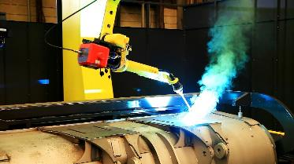
Image 1: The TPS 600i and the PMC welding package in use on an excavator bucket.

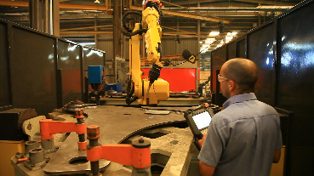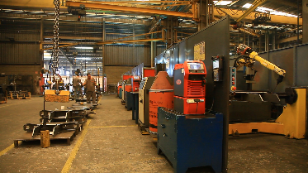
Bild 2 & 3: Painco benefirts from the intelligent functions of the modern system platform, which delivers an extremely stable welding process.

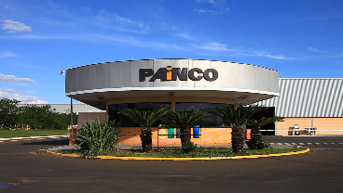
Bild 4: Painco in Rio das Pedras, São Paulo


Bild 5: Rafael Severino, Painco Operations Manager

Copyright to photos: Fronius International GmbH, reproduction free of charge

Link TPS600i:
https://www.fronius.com/en/welding-technology/products/manual-welding/migmag/tpsi/tpsi/tps-600i

This press release, and the pictures, are available for download from:
www.fronius.com/en/welding-technology/infocentre/press/painco-tps600i

Business Unit Perfect Welding
Fronius Perfect Welding is an innovation leader for arc welding and a global market leader for robot-assisted welding. As a systems provider, the Fronius Welding Automation division also implements customized automated complete welding solutions, for the construction of containers or offshore cladding for example. The range is rounded off by power sources for manual applications, welding accessories, and a broad spectrum of services. With more than 1000 sales partners worldwide, Fronius Perfect Welding has great customer proximity.

Fronius International GmbH
Fronius International is an Austrian company with headquarters in Pettenbach and other sites in Wels, Thalheim, Steinhaus and Sattledt. Founded by Günter Fronius in 1945, this long-standing company with a rich tradition will be celebrating its 75th anniversary in 2020. What began as a local one-man venture has grown into a global player with more than 5440 employees worldwide working in the areas of welding technology, photovoltaics and battery charging systems. Its export ratio of around 93 percent is achieved with 34 international Fronius subsidiaries and sales partners/representatives in more than 60 countries. Moreover, its innovative products and services and its portfolio of 1264 registered patents make it an innovation leader on the world market.

For more information, please contact:
Fronius International GmbH, Communication / Public Relations, Leonie DOPPLER (Ms.),
Froniusplatz 1, A 4600 Wels, Austria, Phone +43 (7242) 241-3884,
Fax: +43 (7242) 241-954938, E-Mail: doppler.leonie@fronius.com

Please send an author's copy to our agent:
a1kommunikation Schweizer GmbH, FAO Kirsten Ludwig,
Oberdorfstraße 31 A, 70794 Filderstadt, Germany,
Tel.: +49 (0)711 9454161-20, e-mail: Kirsten.Ludwig@a1kommunikation.de

For more exciting updates, visit our blog at blog.perfectwelding.fronius.com and follow us on Facebook (froniuswelding), Twitter (froniusintweld), LinkedIn (perfect-welding), Instagram (froniuswelding) and YouTube (froniuswelding)!

