BUSINESS UNIT PERFECT CHARGING

PRESS RELEASE

Fronius Selectiva battery charging systems now feature an innovative cold logistics option:
Conserve battery power in refrigerated environments

Extreme temperatures often make day-to-day work more difficult in the logistics sector. When storing and transporting fresh and frozen foods, it is essential that an uninterrupted cold chain is in place – something logistics providers have to contend with, particularly during the warm summer months. However, low ambient temperatures like those prevalent in refrigerated environments, also pose huge challenges for drive batteries and the operators of electric forklift trucks. In order to tackle this, Fronius Perfect Charging has developed a cold logistics option for its Selectiva battery charging system, which ensures that both the battery and the forklift truck work optimally even in very low temperatures.

Low temperatures drastically reduce the performance and service life of drive batteries. This means they usually do not have sufficient energy for a whole shift. At minus 15 degrees, for example, batteries only perform at around 60 percent of their usual capacity. To counteract this drop in performance, Fronius is now offering its own specially developed cold logistics option for its Selectiva 4.0 devices. The battery charging system with pre-set temperature sensors automatically selects the correct amount of energy to optimally charge the battery. This means batteries and forklift trucks are ready for use at all times without long waiting times.

High performance even at very low temperatures
Thanks to Fronius’ RI charging process, the Selectiva devices flexibly charge lead-acid batteries of different sizes, voltage and capacity, which facilitates assignment and reduces operating errors. Additional special features like the cold logistics option enable the reliable operation of forklift trucks even in difficult environments. Users thus benefit from high availability of their forklift truck fleet and can reduce their operating costs in the long term at the same time.

2,038 characters incl. spaces

Meta title: Cold logistics: Fronius battery charging technology for use in refrigerated environments

Meta description: The Selectiva battery charging systems from Fronius impress with an innovative cold logistics option for use in low temperatures.

Keywords: Fronius Perfect Charging, battery charging technology, charging system, drive battery, Selectiva, cold logistics, temperature, cold

Image caption:
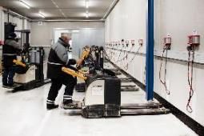
Fronius Perfect Charging has developed its own cold logistics option for its Selectiva battery charging systems to cope with the challenges of cold logistics.

Copyright to photos: Fronius International GmbH, reproduction free of charge

The high-resolution image is available for download here.

Contact details for this publication:
Company name: | Fronius Perfect Charging
E-mail: | perfect.charging@fronius.com
Website: | www.fronius.com/intralogistics
YouTube: | www.youtube.com/FroniusCharging
LinkedIn: | www.linkedin.com/showcase/perfect-charging
Phone International: | +43 7242 2410
Phone UK & Ireland: | +44 1908 512300
Phone India: | +91 97654 98881

For more exciting updates, follow us on LinkedIn (perfect-charging)
and YouTube (FroniusCharging)!

About Fronius International GmbH

Fronius International is an Austrian company with headquarters in Pettenbach and other sites in Wels, Thalheim, Steinhaus and Sattledt. Founded by Günter Fronius in 1945, this long-standing company with a rich tradition will be celebrating its 75th anniversary in 2020. What began as a local one-man venture has grown into a global player with more than 5440 employees worldwide working in the areas of welding technology, photovoltaics and battery charging systems. Its export ratio of around 93 percent is achieved with 34 international Fronius subsidiaries and sales partners/representatives in more than 60 countries. Moreover, its innovative products and services and its portfolio of 1264 registered patents make it an innovation leader on the world market.

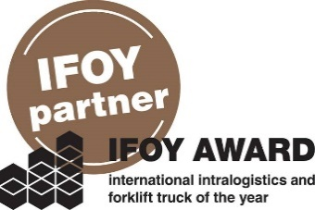 | Fronius is an official partner of the annual IFOY AWARD (International Intralogistics and Forklift Truck of the Year), which recognises the best forklift trucks and application solutions in the industry, trade and service sectors.

For more information, please contact:
Fronius International GmbH
MMag. Sonja POINTNER, +43 (7242) 241-6436, pointner.sonja@fronius.com
Fronius International GmbH, Froniusplatz 1, 4600 Wels, AUSTRIA

Please send an author's copy to our agent:
a1kommunikation Schweizer GmbH, Mrs. Kirsten Ludwig,
Oberdorfstraße 31 A, 70794 Filderstadt, GERMANY,
Tel.: +49 (0)711 9454161-20, e-mail: Kirsten.Ludwig@a1kommunikation.de

